[Working title]: Evaluating the Role of Endophyte-Rich Leaves in Protecting Tropical Trees Against a Generalist Herbivore and a Pathogen

Authors:

Bolívar Aponte Rolón1*, A. Elizabeth Arnold2,3,4, Mareli Sánchez Juliá1, Sunshine A. Van Bael1

1Department of Ecology and Evolutionary Biology, Tulane University, 6823 St. Charles Avenue, New Orleans, LA 70118

2 School of Plant Sciences, University of Arizona, Tucson, AZ 85721

3Department of Ecology and Evolutionary Biology and the Bio5 Institute, University of Arizona, Tucson, AZ 85721

*For correspondence: baponterolon@tulane.edu

Author contributions: A.E.A., S.A.V. designed research study. M.S.J. and B.A.R. performed experiments and collected data. B.A.R. and M.S.J. analyzed data. B.A.R. wrote the manuscript with input from all authors. All authors gave final approval for publication.

# 1. Abstract

Leaf traits such as leaf chemistry, lifespan, toughness, and leaf mass per area (LMA) are a plant’s first line of defense against natural enemies. Plants that invest more in leaf tissue with longer lifespans and higher LMA consequently must invest in constitutive defenses (e.g., leaf toughness, thickness, and dense cell walls) as well. In contrast, plants that invest little in leaf nutrients and have low LMA may have greater levels of induced defenses. Together, leaf traits, whether constitutive or induced, represent an environmental filter for leaf microbial communities, especially foliar endophytic fungi (FEF), which may in turn play a role in plant defense. Our overarching hypothesis is that FEF alter leaf defenses via tripartite interactions among FEF, leaf traits and plant enemies. To evaluate this hypothesis, we inoculated seedlings from seven tropical tree species with natural and diverse endophyte communities. We confirmed the success of our inoculations of low FEF (*E-*) and high FEF (*E+*) treatment groups via culturing and culture-free amplicon sequencing. We then measured leaf removal by leaf-cutter ants (*Atta colombica*) and leaf necrosis due to a generalist fungal pathogen (*Calonectria* sp.). We observed statistically significant lower herbivory in the *E+* treatment compared to the *E-* treatment when we combined all host species. We did not observe significant differences in pathogen damage between *E-* and *E+* treatments when we combined all host species. However, we did see significant differences between exposed and non-exposed pathogen leaves within the *E-* treatment group and within the *E+* treatment group. Dimensionality reduction for leaf traits revealed correlations among LMA, toughness, thickness, and anthocyanin levels. Previous research showed that FEF abundance, diversity, and composition vary as a function of these leaf traits, suggesting that FEF community traits should be integrated into such models to understand their relative importance in defining leaf defense. In turn, indicator species analyses reveal functional traits and taxonomic identities of FEF associated with high- and low leaf damage by natural enemies, suggesting new insights into cryptic roles of foliar symbionts in extending and modifying plant defenses in tropical forests.

# 2. Keywords:

*Atta colombica*, *Calonectria*, foliar fungal endophytes, herbivory, pathogen, symbioses, tropical trees

# 3. Introduction

Vascular plants encountered many challenges in their expansion inland: new climates, rising CO2 (Leakey & Lau, 2012), unique substrates, and stressors like water allocation and transfer. Angiosperms have been successful throughout their evolutionary history by developing an array of strategies to combat biotic (Feild & Arens, 2005) and abiotic (Leakey & Lau, 2012) selective pressures. Strategies against stressors that damage their leaf tissue range from alkaloids and secondary metabolites (e.g., jasmonic acid) to structures that deter potential pests (e.g., thorns/modified leaves). Leaf functional traits such as shape, leaf thickness, leaf strength, leaf mass per area (LMA), and anthocyanins are plant’s first line of defense against herbivores and pathogens, key selective evolutionary pressures (Anderson et al., 2010; Niklas et al., 2023 ).

Leaf defenses fall within the leaf economic spectrum (LES) which on one end has leaves with high nutrient content, low leaf mass per area (LMA), thin leaves blades and thin celled walls associated with short-lived leaves, on the other end, leaves with low nutrient content, high LMA, thick leaf blades and cell walls associated with long-lived leaves (Mason & Donovan, 2015; Wright et al., 2004). The investment in baseline constitutive defenses results in leaves with longer lifespans (Kitajima et al., 2012; Kitajima et al., 2013). While plants that invest little in functional traits such as leaf nutrient content and LMA are potentially more capable of having greater induced defense levels (Kitajima et al., 2013; Poorter & Bongers, 2006; Wright et al., 2004). Leaf functional traits are expressed differentially across species and are influenced by their life history and the environment they occupy. Leaf functional traits, whether constitutive or induced, influence associated leaf microbial communities capable of colonizing leaf tissue (Saunders et al, 2010). In doing so, plants can gain or lose potential allies capable of playing an essential role in the fight against herbivores and pathogens, ultimately contributing to their ecological and evolutionary success (Friesen et al., 2011).

Leaf microbial communities, such as foliar endophytic fungi (FEF), are found inside the leaf tissue of all vascular land plants (Currie et al., 2014; Rodriguez et al., 2009). In tropical forests, FEF transmit horizontally through ambient spore fall (Arnold et al., 2000). Newly flushed leaves are free of FEF presenting fungal spores with challenges to colonization that will ultimately determine FEF communities. They generally grow asymptomatically within leaves (Porras-Alfaro & Bayman, 2011). Nevertheless, FEF have been found to modulate leaf functional traits, especially with regard to the expression of secondary metabolites, sensitivity to drought, photosynthetic rates an efficiency, and defense against natural enemies (Arnold et al., 2003; Arnold & Engelbrecht, 2007; Bittleston et al., 2011; Estrada et al., 2013; Friesen et al., 2011; Mejía et al., 2014). Such effects have not been examined systematically and quantitatively, but are critical to understanding the species interactions in tropical forests relevant to plant survival, performance, and productivity and downstream ecosystem services [McGill et al. (2006). Tellez et al. (2022) highlighted how FEF communities in tropical trees structure along specific leaf functional traits, thus extending the LES framework by including diverse and ecologically important FEF. The potential FEF have to alter where plants fall in the LES offers a useful lens to ask: what is the role of FEF in plant defenses against herbivores and pathogens and what are the trade-offs. Our grasp of the role of FEF in plant defenses is critical to our understanding of plant-enemy interactions and the maintenance of plant diversity in tropical forests.

In this study, we set out to investigate the role of FEF abundance, diversity and community composition in the modulation of leaf functional traits and plant’s response to herbivory and pathogen damage. This work builds upon experiments that used single plant species to plant enemies (Estrada et al., 2013; Mejía et al., 2008, 2014) by incorporating seven phylogenetically distinct tropical tree species and two plant enemies. We hypothesized that FEF improve leaf defenses against generalist herbivores and pathogens, especially in plants that invest less in constitutive defenses (e.g., thin leaves and short-lived). Alternatively, plants that invest more in constitutive defenses rely less on induced FEF acquisition. To test our hypothesis we designed an experiment that manipulated tropical tree seedlings and measured leaf damage (herbivory and pathogen infection) and a subset of leaf functional traits: leaf mass per area (LMA) , leaf thickness (LT), leaf punch strength (LPS), and anthocyanins (ACI), in response to high and *E-* treatments. As plant enemies, we used as model systems leaf-cutter ants, *Atta colombica* (Formicidae), for a generalist herbivore and *Calonectria* sp. (Nectriaceae) for a generalist pathogen. We predicted the following: 1) Leaf-cutter ants and *Calonectria* sp. would cause less leaf damage (herbivory through leaf tissue removal and leaf necrosis through pathogen infection, respectively) on leaves with higher FEF abundance, richness and diversity composition; 2) Tree species with leaf functional traits on the low end of the economic spectrum (e.g., lower leaf mass per area) would have less herbivory and pathogen damage when treated with high FEF densities compared to their *E-* counterparts; 3) Conversely, tree species with leaf functional traits of the high side of the economic spectrum (e.g., greater leaf mass per area) treated with *E+* would have no differences in herbivory and pathogen damage compared to their low FEF counterparts; 4) We anticipated that leaves with leaf functional traits on the high end of the economic spectrum would be less attractive to leaf-cutter ants, but *E-* in them may outweigh this selection factor. To test our predictions, we addressed the following questions:

1. How do FEF high and low treatment differs in terms of abundance, richness, diversity, and community composition?
2. How do leaf functional traits differ between FEF high and low treatments?
3. What is the relationship between FEF abundance, richness, diversity and species composition and herbivory and pathogen damage?
4. What is the relationship between leaf functional traits and herbivory or pathogen damage in high and low FEF treatment groups?

This is the first study to examine the interplay of FEF communities and leaf functional traits in plant defenses against *Atta colombica* and *Calonectria* sp. in tropical tree species. Integrating the role FEF communities into a conceptual framework that includes trade-offs to plants’ constitutive and induced defenses in response to natural enemies will help us understand the importance FEF communities in the maintenance of plant diversity in tropical forests.

# 4. Materials and Methods

### 4.0.1 Study site and seedling rearing

The species, *Theobroma cacao*, *Dypterix* sp., *Lacmellea panamensis*, *Apeiba membranacea*, *Heisteria concinna*, *Chrysophyllum caimito*, and *Cordia alliodora* were chosen due to their variance in leaf functional traits (J.Wright *unpublished data*). Seeds from maternal sources were collected from the forest floor at Barro Colorado Island (BCI) in central Panama (9°050N, 79°450W) during January - April 2019. The average annual precipitation at BCI is 2,600 mm and the pronounced wet season ranges from May to December (Leigh et al., 1996). In preparation for the experiment, seeds were surface sterilized by soaking in water and rinsing in sodium hypochlorite (NaClO) and ethanol (EtOH). Seed from each species had a species-specific sterilization protocol (see Supplementary Materials). Seed germination and the experiment was carried out at the Santa Cruz Field Facility of the Smithsonian Tropical Research Institute in Gamboa, Panama (9°070N, 79°420W). We germinated and reared seedlings in a clean and shaded greenhouse where we enclosed four tables with a PVC pipe frame and covered it in 3 mil clear plastic sheet; two plastic enclosures with two tables each. The enclosures allowed us to grow plants at ambient temperature and moderate light while providing protection from rain and most fungal spores. This allowed us to rear seedlings with yielding zero to low endophyte densities (Bittleston et al., 2011). To ensure sterile conditions throughout the experiment, we cleaned table surfaces and walls of the enclosures on a weekly basis with 70% EtOH and 0.5 % NaClO. We germinated seedlings in sterilized trays containing a 3:1 mix of soil and river sand that was autoclaved for two one-hour cycles at 121°C prior to planting. Individual seedlings were transferred from germination trays to a 24-cell tray (each cell ~380 mL) containing the same autoclaved soil and sand mixture. We took precaution to extract complete root systems from the seedlings. See Supplementary Materials for further details on plastic tray and pot sterilizations protocols.

Seedlings reached a minimum of 3-4 true leaves before endophyte inoculation. We placed seedlings on separate tables designated for spore fall inoculation and non-inoculated treatment groups within the enclosures. Seedlings of the same species but different treatment groups were in the same enclosure. We watered seedlings at the soil level to minimize endophyte spore germination in the enclosures (Arnold et al., 2003).

### 4.0.2 Fungal endophyte inoculation

To inoculate seedlings with FEF, we took 10 individual seedlings of each species and exposed them to 10 nights of spore fall to achieve a high FEF load (*E+*) and 10 homologous plants were kept inside the greenhouse plastic enclosure to maintain a low FEF load (*E-*). Plants exposed to spore fall were placed on a table near (~10 m) the forest edge at dusk (~18:00 hours) and returned to the greenhouse at dawn (~07:00 hours) (Bittleston et al., 2011). We sprayed the *E+* seedlings with water to simulate rain and to promote endophyte spore germination and infection of leaves. We repeated this process for 10 consecutive nights. Low FEF plants (*E-*) were watered only at the soil level and shuffled and moved inside the greenhouse to simulate similar treatment as *E+* seedlings.

### 4.0.3 Leaf trait measurements

Three mature leaves were haphazardly collected from each of the individual plants in each treatment (*E+*, *E-*) within 7-10 days after inoculation treatment. Anthocyanin (ACI) content and leaf thickness (LT) were measured while the leaf was still attached to the plant. We measured anthocyanin content with ACM-200plus (Opti-Sciences Inc. Hudson, New Hampshire, U.S.A.) on three haphazardly selected locations (working from the petiole out to the leaf tip) on the leaf surface of three haphazardly selected leaves for a total of nine measurements per plant (Tellez et al., 2022). To account for leaf thickness, the ACM-200 calculates an anthocyanin content index (ACI) value from the ratio of % transmittance at 931 nm/% transmittance at 525 nm Inc. (n.d.). On compound leaves (i.e., *Dypterix* sp.) we measured at three different leaflets. Leaf thickness (μm) was measured with a Mitutoyo 7327 Micrometer Gauge (Mitutoyo, Takatsu-ku, Kawasaki, Japan) at six different points on the leaf lamina; at the base, mid-leaf and tip on both sides of the mid-vein, taking care to avoid major and secondary veins. After ACI and leaf LT measurements were completed, we removed the leaves from their stems, placed them inside a plastic bag (i.e., ZiplocⓇ), place in an ice chest and moved them to the lab for further measurements. Leaf punch strength (LPS) was measured with an Imada DST-11a digital force gauge (Imada Inc., Northbrook, IL, United States) by conducting punch-and-die tests with a sharp-edged cylindrical steel punch (2.0 mm diameter) and a steel die with a sharp-edged aperture of small clearance (0.05 mm). The leaf punch measurements were taken at six different points of the leaf by puncturing the lamina at the base, mid-leaf and tip on both sides of the mid-vein, avoiding minor leaf veins when possible (Tellez et al., 2022). Once LPS was measured, we used a 7 mm diameter punch hole to puncture disks for leaf mass per area (LMA) measurements. We collected three disks per leaf (see Supplementary material for details). The disk punches dried at 60 °C for 48-72 hours. before being weighed.

### 4.0.4 Leaf tissue preparation for molecular work

The selected leaves were also used to profile endophyte community composition, abundance, and richness via amplicon sequencing (Illumina MiSeq). The leaf tissue remaining after the leaf trait measurements had the main vein and margins excised so that only the lamina remained. The lamina was haphazardly cut into 2 x 2 mm segments, enough to obtain a total of 16, and surface sterilized by sequential rinsing in 95% ethanol (10 s), 0.5 NaOCl (2 mins) and 70% ethanol (2 mins), as per (Arnold et al., 2003; Higgins et al., 2014; Tellez et al., 2022). After, leaves were air-dried briefly under sterile conditions. Sixteen leaf segments per leaf, a total of forty-eight leaf segments per plant, were plated in 2% malt extract agar (MEA), sealed with Parafilm M (Bemis Company Inc., U.S.A.) and incubated at room temperature. The cultured leaf segments were used to estimate endophyte colonization of *E-* and *E+* leaves. The presence or absence of endophytic fungi in the leaf cuttings was assessed 7 days after plating. The remaining sterilized leaf lamina was preserved in sterile 15 mL tubes with ~ 10 mL CTAB solution (1 M Tris–HCl pH 8, 5 M NaCl, 0.5 M EDTA, and 20 g CTAB). Leaf tissue in CTAB solution was used for amplicon sequencing (described in detail below). All leaf tissue handling was performed in a biosafety cabinet with all surfaces sterilized by exposure to UV light for 30 minutes and cleaned sequentially in between samples with 95% ethanol, 0.5% NaOCl and 70% ethanol to prevent cross contamination.

## 4.1 Amplicon sequencing

Leaf tissue in CTAB solution was stored for 2 months at room temperature prior to being placed at -80 °C for 3 months before extracting DNA. In preparation for DNA extraction, we decontaminated all instruments, materials, and surfaces with DNAway (Molecular BioProducts Inc., San Diego, CA, United States), 95% Ethanol, 0.5 % NaOCl, and 70 % Ethanol, and subsequently treated with UV light for 30 minutes in biosafety cabinet. We then transferred 0.2 – 0.3 g of leaf tissue into duplicate sterile 2mL tubes, resulting in 2 subsamples. Total genomic DNA from subsamples was extracted as described in U’Ren & Arnold (2017). In brief, we added two sterile 3.2 mm stainless steel beads to each tube and proceeded to lyophilize samples for 72 hours to fully remove CTAB content from tissue. After this period, we submerged the sample tubes in liquid nitrogen for 30s and proceeded to homogenize samples to a fine powder for 45 s in FastPrep-24 Tissue and Cell Homogenizer (MP Biomedicals, Solon, OH, USA). Afterwards, we repeated the decontamination procedure described before and used QIAGEN DNeasy 96 PowerPlant Pro-HTP Kit (U’Ren & Arnold, 2017) (QIAGEN, Valencia, CA, USA). After all genomic DNA was extracted, we pooled the subsamples for each individual sample before amplification. We used sterile equipment and pipettes with aerosol-resistant tips with filters in all steps before amplification. We followed a two-step amplification approach previously described by Sarmiento et al. (2017) and U´Ren & Arnold (2017). We used primers for the fungal ITSrDNA region, ITS1f (5’-CTTGGTCATTTAGAGGAAGTAA-3’) and ITS4 (5’-TCCTCCGCTTATTGATATGC-3’) with modified universal consensus sequences CS1 and CS2 and 0–5 bp for phase-shifting. Every sample was amplified in two parallel reactions containing 1-2 µL of DNA template (U’Ren & Arnold, 2017; see also Tellez et al., 2022). We visualized PCR (PCR1) reactions with SYBR Green 1 (Invitrogen, Carlsbad, CA, USA) on 2% agarose gel (Oita et al., 2021). Based on the electrophoresis band intensity, we combined parallel PCR1 reactions and diluted 5 µL of amplicon product with molecular grade water to standardize to a concentration of 1:15 (Sarmiento et al., 2017 for details; Tellez et al., 2022). We included DNA extraction blanks and PCR1 negatives in this step. We used a separate set of sterile pipettes, tips, and equipment to reduce contamination. We used a designated PCR area to restrict contact with pre-PCR materials (Oita et al., 2021). We used 1 µL of PCR1 product from samples and negative control for a second PCR (PCR2) with barcode adapters (IBEST Genomics Resource Core, Moscow, ID, USA). Each PCR2 reaction (total 15 µL) contained 1X Phusion Flash High Fidelity PCR Master Mix, 0.075 µM of barcoded primers (forward and reverse pooled at a concentration of 2 µM) and 0.24mg/mL of BSA following Sarmiento (2017) and U’Ren & Arnold (2017). Before final pooling for sequencing, we purified the amplicons using Agencourt AMPure XP Beads (Beckman Coulter Inc, Brea, CA USA) to a ratio of 1:1 following the manufacturer’s instructions. The products were evaluated with Bio Analyzer 2100 (Agilent Technologies, Santa Clara, CA, USA) (Tellez et al., 2022). We quantified the samples through University of Arizona Genetics Core, and subsequently diluted them to the same concentration to prevent over representation of samples with higher concentration (Sarmiento et al., 2017). Amplicons were normalized to 1 ng/µL, then pooled 2 µL of each for sequencing. No contamination was detected visually or by fluorometric analysis. To provide robust controls we combined 5 µL of each PCR1 negative and the DNA extraction blanks and sequenced them as samples. Ultimately, we combined samples into a single tube with 20 ng/µL of amplified DNA with barcoded adapters for sequencing on the Illumina MiSeq platform with Reagent Kit v3 (2 × 300 bp) following protocols from the IBEST Genomics Resource Core at the University of Idaho, USA. Again, we included the DNA extraction blanks and two PCR1 negatives and sequenced with samples. Sequencing yielded 3,778,081 total ITS1 reads.

### 4.1.1 Mock Communities

We processed and sequenced 12 mock communities following the methods described above. This allowed us to assess the quality of our NGS data set. We used two mock communities that consisted of PCR product from DNA extractions of 32 phylogenetically distinct fungi, representing lineages that are typically observed as endophytes: Ascomycota, Basidiomycota, Zygomycota and Chytridiomycota (Oita et al., 2021; see Daru et al., 2019 for details). In brief, we used six mock communities with equimolar concentrations of DNA from all 32 fungal taxa and another six mock communities with tiered concentrations of DNA from the same fungal taxa (Daru et al., 2019). Each mock community was sequenced five times (i.e., five replicates) (Oita et al., 2021). The read abundance from the equimolar and tiered communities was positively associated with the expected read number (*R2adj* = 0.87, *p* < 0.0001, Fig. S9). Using mock communities allowed us to evaluate the sequencing effectiveness in communities with known composition and structure (Bowman & Arnold, 2021). Henceforth, we used read abundance as a relevant proxy for biological OTU abundance (U’Ren et al., 2019).

### 4.1.2 Bioinformatic analyses

We used VSEARCH (v2.14.1) for *de novo* chimera detection, dereplication and sequence alignment. VSEARCH is an open-source alternative to USEARCH that uses an optimal global aligner (full dynamic programming Needleman-Wunsch), resulting in more accurate alignments and sensitivity (Rognes et al., 2016). For mock communities and experimental samples, we used forward reads (ITS1) for downstream bioinformatics analyses due to their high quality, rather than reverse reads (ITS4). Following Sarmiento et al. (2017), we concatenated all reads in a single file and used FastQC reports to assess Phred scores above 30 and determine the adequate length of truncation. We processed 892,713 of sequence reads from mock communities and 3,778,081 from experimental samples. We truncated mock community and experimental sample reads to a length of 250 bp with command fast_trunclen and filtered them at a maximum expected error of 1.0 with command fast_maxee. We then clustered unique sequence zero radius OTUs (that is, zOTUs; analogous to amplicon sequence variants (Callahan et al., 2016)), by using commands derep_fulllength and minseqlength set at 2. Sequentially we denoised and removed chimeras from read sequences with commands cluster_unoise, and uchime3_denovo, respectively. Finally, we clustered zOTUs at a 95% sequence similarity with command usearch_global and option id set at 0.95. After which, 3,035,960 sequence reads from experimental samples remained. Taxonomy was assigned with the Tree-Based Alignment Selector Toolkit [v2.2; Carbone et al. (2019)] by placing unknowns within the Pezizomycotina v2 reference tree (Carbone et al., 2017). ITS sequences were blasted against the UNITE database by the ribosomal database project (RDP) classifier. A total of 2147 OTUs hits were obtained and are composed of 68.6% Ascomycota, 26.8% Basidiomycota,<0.05% Chytridiomycota, <0.05% Glomeromycota, <0.05% Mortierellomycota, <0.05% Rozellomycota, 0.05% Kickxellomycota, and 4.2 % BLAST hit misses. Only OTUs representing Ascomycota were used for downstream statistical analyses since foliar endophyte communities in tropical trees are dominated by Ascomycota (Arnold & Lutzoni, 2007). For each OTU identified, we removed laboratory contaminants from experimental samples by subtracting the average read count found in control samples from the DNA extraction and PCR steps. Our analysis of mock communities allowed use to identify and remove false OTUs from experimental samples, those with fewer than 10 reads, and remove 0.1% of the read relative abundance across all samples (Oita et al., 2021). Removed reads represent the frequency of reads classified as contamination in the mock communities relative to the expected read count. Three experimental samples from *Theobroma cacao* (*n*=2) and *Apeiba membranacea* (*n*=1) were removed from all analyses due to incomplete entries. After pruning taxa with zero reads from experimental samples, we identified 260 OTUs found exclusively in control (*E-*) plants (*n*=78) and deemed them as artifacts resulting from the greenhouse conditions. Consequently, these were consistently eliminated from treatment (*E+*) plants across all species. We converted reads for each fungal OTU to proportions of total sequence abundance per sample to reduce differences in sampling effort, following previous studies (Weiss et al. (2017); McMurdie & Holmes (2014) ). We then removed singletons and obtained an average of 2,464,558 sequence reads in 529 Ascomycota OTUs across 156 experimental samples of 7 tree species. All analyses post taxonomic assignment were performed in R [v. 4.3.2; R Core Team (2023)] using the phyloseq package (McMurdie & Holmes, 2013) and custom scripts (see Supplementary Material).

### 4.1.3 Herbivore assays

A fresh fourth leaf was used in ant assays. To assess leaf-cutter ant damage, we introduced one detached leaf per plant per treatment to an actively foraging leaf-cutter ant colony for a two-hour assay. We presented leaf-cutter ant colonies with a choice of an *E+* or an *E-* leaf on one disposable plastic plate next to an active nest trail. Carefully, we collected and placed debris from the trail leading up to the plate to lure ants into the plate. We initiated the ant assay as soon as one ant entered the plate and explored the leaf contents (for ~ 10-20 seconds). Every five minutes we took a digital photo of the choice arena until about 75% of the leaf content of one of the leaves was consumed. We used the digital photo at time zero and at the end of trial to quantify the leaf area removed using ImageJ [v1.52r; Schneider et al. (2012)]. Ant recruitment was estimated by counting individuals in the choice arena throughout trial event.

### 4.1.4 Pathogen assays

For the pathogen assays, we introduced an agar plug inoculated with hyphae of *Calonectria* sp. (*P+* treatment), and an agar plug without the pathogen (*P-* control) to similarly aged/sized leaves within 10-14 days after endophyte inoculations (Gilbert & Webb, 2007). Leaves with the *P+* or *P-* treatment were misted with sterile water two times a day (morning and afternoon) to maintain moisture. After four days, we removed the plugs and took digital photos to analyze leaf area damage using ImageJ [v1.52r; Schneider et al. (2012)].

### 4.1.5 Replication Statement

|  |  |  |
| --- | --- | --- |
| **Scale of inference** | **Scale at which the factor of interest is applied** | **Number of replicates at the appropriate scale** |
| Leaf functional traits | Species | Treatment = 2 (E-, E+), Tropical tree species = 7, Replicates per species = 5. Replicate leaves per plant = 3 |
| Genomic data | Species | Treatment = 2 (E-, E+), Tropical tree species = 7, Replicates per species = 5 |
| Herbivore assays | Species/individual | Treatment = 2 (E-, E+), Tropical tree species = 7, Replicates per species = 5, Replicates per plant = 1 |
| Pathogen assays | Species/individual | Treatment = 2 (E-, E+), sub-treatment = 2 (control and pathogen) for pathogen trials, Tropical tree species = 7, Replicates per species = 5, Replicates per plant = 1 |

### 4.1.6 Statistical Analyses

We explored how leaf functional traits and FEF correlated to herbivory and pathogen damage on leaves. We present the analyses for each tree species at the leaf and at the plant level. Leaf functional traits are presented at the leaf level, while FEF data was explored and is presented at the plant level. In analyses where leaf functional traits and FEF are combined we used averages of the leaf functional traits.

First, we compared the means of herbivory (%) damage, and leaf functional traits for each species and treatment groups using paired two-sided Student’s t-Test and analysis of variance (ANOVA) with the compare_means and stat_compare_means functions from the ggpubr package in R (Kassambara, 2023a), which wrap and extend the anova and t.test functions from the stats package (R Core Team, 2023) and facilitate plotting. Additionally, to facilitate comparison between group levels we used the pairwise_t_test function from the rstatix package (Kassambara, 2023b) when we compared pathogen (%) damage means. This function also wraps and extends base *R* functions. We adjusted *p* values to account for false discovery rates in multiple comparisons by using “BH” method (Benjamini & Hochberg, 1995).

Secondly, we calculated a Bray-Curtis dissimilarity matrix with our OTU relative abundance data and computed a distance-based redundancy analysis (dbRDA) by applying the dbRDA function in the vegan package to our dissimilarity matrix (Oksanen et al., 2022). We computed forward model selection for dbRDA analysis with the ordistep function which selects terms based on *p* values (Blanchet et al., 2008; Oksanen et al., 2022). We started with our initial model containing only the intercept (dissimilarity_matrix ~ 1) and setting the functions arguments to the following: scope = formula(*m*), where *m* is the formula with a defined range including leaf functional traits, tree species and treatment groups; Pin = 0.5, Pout = 0.05, trace = T, permutations = how(nperm = 999), steps = 50.The dbRDA is considered analogous to a permutational analysis of variance (PERMANOVA) with non-Euclidean distance (Anderson, 2017; McArdle & Anderson, 2001). Its corresponding visualizations appropriately illustrate underlying patterns of compositional differences (Anderson, 2017; Legendre & Anderson, 1999; McArdle & Anderson, 2001). We used the anova.cca function to assess the marginal significance of constraining variables (Legendre et al., 2011; Legendre & Legendre, 2012; Oksanen et al., 2022) Applied here to visualize associations between leaf functional traits and FEF communities in host tree species and treatment groups.

Thirdly, we arbitrarily designated percent leaf damage in herbivore assays as high (>70%), medium (31-69%) and low (<30%) and in pathogen assays as high (>30%) and low (<29%). These categories allowed us to explore the correlations between host tree species and specific FEF OTUs. To achieve this we used the multipatt function from the indicspecies package in *R* (De Cáceres & Legendre, 2009). We calculated the point biserial correlation coefficient for each OTU at all tree species and treatment group combinations by applying the multipatt function with arguments func= “r.g” and control = how(nperm=999) to our OTU abundance matrix (De Cáceres & Legendre, 2009). Like with other statistical tests performed, we adjusted *p* values to account for false discovery rates in multiple comparisons by using “BH” method (Benjamini & Hochberg, 1995) in the p.adjust function from the stats package (R Core Team, 2023). We then filtered the adjusted a *p* value with a cutoff of <0.05.

Fourthly, Principal Component Analysis (PCA) was used to reduce dimensions among covariates and reveal underlying interactions between covariates that could influence herbivory and pathogen damage. The PCA was computed using the prcomp function in R statistical software (R Core Team, 2023). A complete PCA was computed with variables ACI, LT, LPS, and LMA. We then proceeded to compute a PCA with the data from leaves of plants used in the herbivory (*n* = 210) and pathogen assays (*n* = 192). We then took from the herbivory and pathogen PCA the principal components that explained the most variance (PC1 and PC2) and regressed them to herbivory (%) and pathogen damage (%). We also regressed ACI, LT, LPS, LMA and Shannon’s Diversity Index to logit transformed herbivory (%) and pathogen damage (%). We used the logit function from the car package for logit transformation of variables and the lm function from the stat package for simple linear regressions (Fox & Weisberg, 2019; R Core Team, 2023).

Lastly, to test how leaf functional traits and FEF communities interact to influence herbivory and pathogen damage in tropical tree species, we used a generalized linear mixed model (GLMM) with herbivory and pathogen damage percentage (logit transformed) as the response variable. To determine which fixed effects to include in the GLMMs we used the vif function from the car package in *R* to calculate the variance inflation factor for all explanatory variables (ACI, LT, LPS, LMA, and Shannon diversity index) (Fox & Weisberg, 2019; R Core Team, 2023). Complementary to this, we calculated Pearson’s coefficient for each pair of leaf functional traits with by creating a correlation matrix and applying the cor function from the stats package to assess correlations among traits (R Core Team, 2023). We opted to maintain explanatory variables LT and LMA, and exclude ACI and LPS from subsequent general linear models (GLMMs) due to high collinearity between the two variables with LMA, *r*(1112) = 0.68, *p* < 0.0001 and *r*(1113) = 0.65, *p* < 0.0001, respectively. We modeled only main effects with explanatory variables, we did not model interactions effects to avoid overfitting models. We used a restricted maximum likelihood estimates for model fit with the lme function from the nlme package (Pinheiro et al., 2023). For our logit herbivory GLMMs we used tree species as a random effect and modeled tree species variance structure with the varIdent argument (Pinheiro et al., 2023). For our logit pathogen damage GLMMs we use tree species as a random effect and modeled a nested variance structure for pathogen treatment within treatment groups per species with the varIdent argument (Pinheiro et al., 2023). We manually compared and selected models based on Akaike Information Criterion (AIC) with a penalty of 2 degrees of freedom (ΔAIC) with the model.sel function from the MuMIn package (Bartoń, 2023). We selected the best-fit model based on the lowest value obtained.

# 5. Results

Seedlings exposed to forest spore fall, *E+*, had a significantly higher proportion of leaf segments colonized by FEF across all species (data from cultures, Fig. S1). Similarly, molecular data set showed that seedlings with *E+* treatment had a significantly higher FEF relative abundance (paired, two-sided *t*-tests, *p* < 0.05) for all tree species when compared to the *E-* treatment (Fig. 1a). Despite these significant differences, there was a high degree of variability in FEF relative abundance within each treatment type (Fig. 1).

We observed general differences in leaf functional traits among species (Table 2). For ACI and LPS we did not find significant differences between treatments (*E-* and *E+*) when we combined all host species (Fig. S2a and Fig. S4a respectively). For LT and LMA we saw statistically significant differences between *E-* and *E+* treatment groups when we combined all host species (Fig S3a and Fig. S5a, respectively). As predicted, we did observe statistically significant lower herbivory in the *E+* treatment compared to the *E-* treatment when we combined all host species, *t*(34) = 2.23, *p* = 0.033 (Fig. 2a). We did not observe statistically significant differences in pathogen damage between *E-* and *E+* treatments when we combined all host species (Fig. 2b). However, we did see significant differences between exposed (*M* = 17.37, *SD* = 12.57) and non-exposed (*M* = 3.49, *SD* = 5.42) pathogen leaves within the *E-* treatment group, *t*(31) = -7.19, *p* < 0.0001 (Fig. 2b) and within the *E+* treatment group: exposed (*M* = 20.04, *SD* = 15.72), non-exposed (*M* = 7.17, *SD* = 17.48), *t*(31) = -3.26, *p* < 0.01 (Fig. 2b). We did not observe significant differences between treatment groups for herbivory and pathogen damage (5) at the species level (Fig. S6a-S6b).

We used a dbRDA analyses to understand FEF community composition across host species and treatment groups. The analyses revealed that 6.34% of the overall variance inf FEF communities was accounted for by the leaf functional traits, the constraining variables. The first axis (dbRDA1) explained 49% and the second axis (dbRDA2) explained 21.3% of the constrained variance (Fig. 3). We observed a high degree of overlap between the FEF communities (Fig. 3) indicating that the communities are similar in composition across host species and treatment groups (Fig. 3). We see tight clustering of FEF communities in *C. cainito* and *L. panamensis* although these are overlapped by *A. membranacea* pointing to a distinct subset composition of FEF OTUs within the latter (Fig. 3). All leaf functional traits significantly correlated with FEF community composition (Fig.3).

There was a core set of OTUs that significantly correlated with host tree species or particular treatments. In summary, 72 out of 569 Ascomycota OTUs were significantly correlated to our host trees species (Table S5). Seedlings used in herbivory assays had 13 OTUs significantly correlated with high herbivory damage (>70%) and 3 and 1 OTUs significantly correlated with medium (31-69%) and low (<30%) herbivory damage, respectively (Table S6). Seedlings used in pathogen damage assays had 11 OTUs significantly correlated with high (>30%) pathogen damage (Table S7). We could not tease apart which OTUs were correlated with leaves treated with control and *Calonectria* sp. agar plugs because the genomic data scale for these trials was at the plant level, not leaf level. For the pathogen assays we found 30 OTUs significantly correlated with *E+* treatment (Table S8)..

The PCA revealed how leaf traits (ACI, LT, LPS and LMA) were related. We plotted leaf trait data according to tree species groups on the PCA axes to show how the variance in the complete data set is explained by PC1 (60%) and PC2 (27%) (Fig. 4a). We observed that ACI, LPS and LMA loadings tracked along PC1 towards more negative values, showing correlation among these traits (Fig. 4a). Traits LT and LPS were orthogonal to each other in Fig. 4a, indicative of low correlation. We note distinct grouping of species along PC1 such as *C. alliodora* in the direction of positive values of PC1 and *C. cainito* towards negative values. Along PC1 we saw distinct and tight clustering according to species for all except *H. concinna* and *A. membranacea* which overlaped with various other species. We noted that LT loading tracked towards negative values along PC2 (Fig. 4a). Clear species groupings were detected, such as *Dypterix* sp. located towards positive values and *L. panamensis* towards negative values of the PC2 axis. We note a similar relationship between the leaf traits with respect to PC1 and PC2 in individual seedlings used for herbivory versus pathogen damage trials (Fig. 4b-4c). The PCA of leaf traits from seedlings used in herbivory trials had a PC1 explaining 57.5% of the variance and a PC2 explaining 28% of the variance in the subset data (Fig. 4b). We saw an inversion of the LT loading in direction of positive values, as well as the main tree species clustered (i.e., *Dypteryx* sp. and *A. membranacea*) along PC2 (Fig. 4b) with respect to Fig. 4a. The PCA of leaf traits from seedling used in pathogen damage trials had a PC1 explaining 64% of the variance and a PC2 explaining 25% of the variance in the subset data (Fig. 4c). We detected similar relationships among leaf traits and PC axes in the pathogen damage subset data (Fig. 4c) when compared to the complete data set (Fig. 4a).

Simple linear regressions of herbivory (%) against PC1 revealed no correlation (*R2adj* = -0.0024, *F*(1, 208) = 0.508, *df* = 208, *p* = 0.447)(Fig. 5a), where positive values represent greater values of ACI, LPS and LMA. Even though we note large spread in the data (Fig. 5a and 5b), we see a statistically significant positive trend of herbivory plotted against PC2 (*R2adj* = 0.079, *F*(1, 208) = 18.9, *p* < 0.0001), where positive values represent greater LT (Fig. 5b). Percent pathogen damage plotted against PC1 revealed a statistically significant correlation (*R2adj* = 0.064, *F*(1, 380) = 26.93 *p* < 0.0001), in which positive values represent greater values of ACI, LPS and LMA (Fig. 5c). We did not see a statistically significant relationship between pathogen damage and PC2 (*R2adj* = 0.002, *F*(1, 380) = 1.60, *p* = 0.207) (Fig. 5d). We found similar patterns in the simple linear regressions performed on the leaf functional traits without reducing dimensions and on logit transformed herbivory and pathogen damage data (Fig. S7 and S8, respectively). We observed a statistically significant positive relationship between herbivory and LT (*R2adj* = 0.081, *F*(1, 208) = 19.45, *p* < 0.0001) when considering the complete data set (Figure S7a). We did not observe statistically significant relationship between herbivory (%) and LPS, ACI, LMA, and Shannon’s diversity index for FEF (Figure S7b - S7e) for the complete data set. However, we did observe a general decline in herbivory as FEF diversity increased which aligns with our predictions. In further detail we see a statistically significant negative relationship between herbivory and Shannon diversity for the *E-* treatment group (*R2adj* = 0.138, *F*(1, 103) = 17.7, *p* < 0.0001) (Figure S7e). We also see an in crease in herbivory for the *E+* treatment group as Shannon’s diversity index for FEF increased, but this is not statistically significant (*R2adj* = 0.024, *F*(1, 103) = 3.55, *p* = 0.062) (Figure S7e). For the simple linear regressions of pathogen damage against leaf functional traits we observed a statistically significant negative relationships between pathogen damage and LPS (*R2adj* = 0.078, *F*(1, 380) = 33.32, *p* < 0.0001), ACI (*R2adj* = 0.033, *F*(1, 380) = 14.34, *p* = 0.0002) and LMA (*R2adj* = 0.030, *F*(1, 380) = 12.6, *p* < 0.001) (Figure S8b - S8d) when considering the complete data set. Pathogen damage did not have a statistically significant correlation with LMA (*R2adj* = -0.001, *F*(1, 380) = 0.50, *p* = 0.482) (Figure S8a). The *E-* and *E+* treatment groups follow the same general trend as the complete data set. Contrary to our predictions, when we observe the complete data set find a statistically significant positive relationship between pathogen damage and Shannon’s diversity index for FEF (*R2adj* = 0.015, *F*(1, 380) = 6.90, *p* < 0.01) (Figure S8e). Upon further scrutiny, only the *E+* treatment group has a statistically significantly positive correlation between pathogen damage and Shannon’s diversity index for FEF (*R2adj* = 0.031, *F*(1, 188) = 7.11, *p* < 0.01) (Figure S8e).

The best-fit for our GLMMs showed that fixed effects LT, LMA, and *E+* treatment group are statistically significant predictors of herbivory damage (Table 3). No measure of FEF abundance or diversity was present in the final model. Leaf mass per area is a significant positive predictor of herbivory with the greatest effect size (estimate = 1741, *t*(200) = 3.53 *p* < 0.001). While LT is a significant negative predictor of herbivory damage (estimate = -0.01, *t*(200) = -2.52, *p* = 0.01) and *E+* as well (estimate = -0.78, *t*(200) = -4.62, *p* < 0.001). The best fit model for pathogen damage did not reveal any of the leaf functional traits as significant predictors (Table 3). Like our previous model, no measure of FEF abundance or diversity was present in final model. Even tough, not significant, LMA showed the greatest effect size (estimate = 171.7, *t*(352) = 0.96, *p* = 0.34).

# 6. Discussion

Our data suggest that foliar endophytic fungi (FEF) communities improve leaf defenses against generalist herbivores and pathogens in tropical trees. For all species combined, we saw that the *E+* treatment group had significantly less herbivory damage than the *E-* treatment group (Figure 2). On a species level, we did not see significant differences between treatment groups (Figure S6a). This is probably due to a small replicate size in treated individuals per species used in herbivory assay trials (see Replication Statement), but we do see that the *E+* group has lower herbivory damage in all tree species (Figure S6a). Such results align with Estrada et al., (2013) findings, were leaf-cutter ant effects were significantly reduced in paper disks and leaves treated with higher densities of a common endophyte. In a laboratory setting, Bittleston et al., (2011) found similar patterns in herbivory reduction using *C. alliodora* treated with high and low FEF loads and laboratory reared colonies of *Atta colombica*. In a field study, Coblentz and Van Bael (2013) found that leaf-cutter ants prefer leaves with a lower FEF abundance when compared to surrounding leaf material (material not selected by ants). Our results track findings from previous studies focusing on single host-endophyte interactions and build upon by using multiple host tree species and field inoculated FEF communities. Our best-fit GLMM for herbivory damage highlight only LMA, LT and *E+* treatment group as strong predictors (Table 3). Using data from all the assays, FEF diversity and community composition correlated negatively with herbivory damage, since we saw reduced herbivory as Shannon diversity index increased (black regression line in Figure S7e). As a caveat to these results, we saw an inverse relationship between the treatment groups with the *E+* group positively correlating to herbivory and *E-* group negatively correlating to herbivory (yellow and pink regression lines, respectively, in Figure S7e). The contrast between GLMM and simple linear regressions point to nuanced role of FEF diversity in combating herbivory; leaf functional traits, LMA and LT, overshadow FEF diversity in our results. The FEF abundance, measured as E+ treatment group also plays a strong role in predicting herbivory, less so diversity and community composition.

We did not observe the same pattern for pathogen damage since there were no significant differences between treatment groups when considering all tree species (Figure 2b). Similar to herbivory damage, pathogen damage was not significantly different across treatment groups per species. Interestingly we see that the *E+* group has equal or slightly higher pathogen damage than the *E-* group in all tree species (Figure S6b). The best-fit GLMM for pathogen damage show LMA and LT as week predictors (Table 3). On the other hand, with simple linear regressions we see a significant increase in pathogen damage as Shannon diversity index increased for the complete data set (Figure S8e). Like our herbivory damage models, the contrast between GLMM and simple linear regression point to a nuanced role of FEF abundance and diversity in combating a pathogen. Pathogen damage significantly increased in the *E+* group as Shannon diversity increased, but the *E-* group did not (Figure S8e). González-Tauber (2016) found the opposite trend when examining *in vitro* the inhibitory effects of the most abundant genera (*Mycosphaerella* sp., *Xylaria* sp., *Diaporthe* sp., and *Penicillium* sp.) in FEF communities isolated from the southern temperate tree *Embothrium coccineum* against three common pathogens (*Botrytis cinerea* , *Fusarium oxysporum* and *Ceratocystis pilifera*). In our case, it is possible that the FEF abundance and diversity acquired from spore-fall have a synergistic interaction with *Calonectria* sp., thus outweighing any benefits provided by single-species interactions, ultimately increasing pathogen damage intensity.

The leaf economic spectrum (LES) allows us to interpret our results based on the functional traits that can have an important role in understanding tripartite plant-insect-pathogen interaction. The LES describes how leaf functional traits with high values are characteristic of long-lived versus short-lived leaves Poorter & Bongers (2006). The LES, thus acts as a host imposed filter which FEF communities have to overcome to colonize leaf tissue, assemble, and carry out their life cycle. We did not measure leaf lifespan directly, but we interpret the values obtained for the leaf functional traits we measured as proxies for leaf lifespan, with the caveat that the traits were measured on seedlings and leaves were relatively young (< 150 days). We saw that species with relatively low values of ACI, LMA, and LPS (Figures S2 - S5) constrained in PC1 axis (Figure 4b) experienced very little herbivory damage (i.e., *Dypteryx* sp.) or had much variability (i.e., *C. alliodora*) (Figure 5a). Species with relatively high values of ACI, LMA, and LPS like *C. cainito* experienced low to moderate herbivory damage (Figure 5a). A similar pattern was evident in the pathogen damage data set (Figure 5c). The contrast in the slopes of the regression lines in Figure 5a and 5c highlight the potential importance LES traits have to counter herbivory and pathogen damage. We view these findings and those presented in Figure S7 as support for our prediction, where leaves on the high end of the LES, are less attractive to leaf cutter-ants but the effects of FEF communities out weigh this selection factor after a certain threshold is reached, as mentioned above.

Comprehending the relationship between the Leaf Economic Spectrum (LES), plant defenses, and FEF communities is crucial for understanding the complex interactions among plants, insects, and pathogens. The Optimal Defense Theory (ODT), as outlined by Stamp (2003), proposes three key predictions about plant defenses. First, a plant’s defense investment is directly proportional to the frequency of attacks, such as herbivory or pathogen intensity, and inversely related to the cost of resources (Holeski et al., 2010). Second, plants tend to allocate resources preferentially to parts with high reproductive value, especially when defense costs are minimal. Third, plants exhibit increased defensive responses after being attacked. This theory suggests that the likelihood of a plant to bolster its defenses following an attack is inversely related to its inherent defense traits(Holeski et al., 2010). Our results point to a preemptive low-cost investment strategy against plant enemies, particularly at the seedling stage, that is leveraged by species specific inherent defense mechanisms. We did not track herbivory or pathogen damage past the seedling stage, so an avenue for inquiry is to investigate how FEF communities change after herbivore and pathogen attacks and to determine the key life stages. A combination of *in vitro* and *in vivo* assays could help elucidate the roles of specific FEF OTUs. The use of *in vitro* assays could help identify the potential anti-herbivore and anti-pathogen qualities of specific FEF OTUs. *In vivo* inoculation assays could help identify the importance that specific FEF OTUs have in different developmental stages, especially in older stages.

# 7. Conclusion

In conclusion, this study significantly advances our understanding of the intricate interactions between plants and their FEF communities, particularly in the context of plant defense mechanisms against herbivores and pathogens. Our findings highlight the complex dynamics of plant-herbivore-pathogen relationships and underscore the importance of FEF communities as a potentially low-cost, preemptive defense strategy for plants, especially during early growth stages. These insights not only shed light on the nuanced role of endophytes in plant ecology but also open avenues for future research, particularly in exploring the strategic resource allocation in plants and the specific contributions of FEF to plant resilience. As we continue to unravel these complex biological interactions, the knowledge gained holds promise not only for ecological theory but also for practical applications in agriculture, forestry, and conservation of the tropics.

# 8. Author Contributions

A.E.A., S.A.V. designed research study. M.S.J. and B.A.R. performed experiments and collected data. B.A.R. and M.S.J. analyzed data. B.A.R. wrote the manuscript with input from all authors. All authors gave final approval for publication.

# 9. Acknowledgements

This research was funded by NSF DEB-1556583 to S.A.V. and NSF DEB-1556287 to A.E.A., and by the School of Plant Sciences and the College of Agriculture and Life Sciences at The University of Arizona (AEA). We thank Ming-Min Lee for laboratory support.

# 10. Conflict of Interest Statement

The authors declare no competing interests.

# 11. Data Availability Statement

# 12. References

Anderson, J. P., Gleason, C. A., Foley, R. C., Thrall, P. H., Burdon, J. B., & Singh, K. B. (2010). Plants versus pathogens: an evolutionary arms race. *Functional Plant Biology*, *37*(6), 499. <https://doi.org/10.1071/fp09304>

Anderson, M. J. (2017). Permutational Multivariate Analysis of Variance ( PERMANOVA ). In *Wiley StatsRef: Statistics Reference Online* (pp. 1–15). Wiley. <https://doi.org/10.1002/9781118445112.stat07841>

Arnold, A. E., & Engelbrecht, B. M. J. (2007). Fungal endophytes nearly double minimum leaf conductance in seedlings of a neotropical tree species. *Journal of Tropical Ecology*, *23*(3), 369–372. <https://doi.org/10.1017/S0266467407004038>

Arnold, A. E., & Lutzoni, F. (2007). Diversity and host range of foliar fungal endophytes: Are tropical leaves biodiversity hotspots? *Ecology*, *88*(3), 541–549. <https://doi.org/10.1890/05-1459>

Arnold, A. E., Maynard, Z., Gilbert, G. S., Coley, P. D., & Kursar, T. A. (2000). Are tropical fungal endophytes hyperdiverse? *Ecology Letters*, *3*(4), 267–274. <https://doi.org/10.1046/j.1461-0248.2000.00159.x>

Arnold, A. E., Mejía, L. C., Kyllo, D., Rojas, E. I., Maynard, Z., Robbins, N., & Herre, E. A. (2003). Fungal endophytes limit pathogen damage in a tropical tree. *Proceedings of the National Academy of Sciences*, *100*(26), 15649–15654.

Bartoń, K. (2023). *MuMIn: Multi-model inference* [Manual]. <https://CRAN.R-project.org/package=MuMIn>

Benjamini, Y., & Hochberg, Y. (1995). Controlling the False Discovery Rate: A Practical and Powerful Approach to Multiple Testing. *Journal of the Royal Statistical Society: Series B (Methodological)*, *57*(1), 289–300. <https://doi.org/10.1111/j.2517-6161.1995.tb02031.x>

Bittleston, L. S., Brockmann, F., Wcislo, W., & Van Bael, S. A. (2011). Endophytic fungi reduce leaf-cutting ant damage to seedlings. *Biology Letters*, *7*(1), 30–32. <https://doi.org/10.1098/rsbl.2010.0456>

Blanchet, F. G., Legendre, P., & Borcard, D. (2008). FORWARD SELECTION OF EXPLANATORY VARIABLES. *Ecology*, *89*(9), 2623–2632. <https://doi.org/10.1890/07-0986.1>

Bowman, E. A., & Arnold, A. E. (2021). Drivers and implications of distance decay differ for ectomycorrhizal and foliar endophytic fungi across an anciently fragmented landscape. *The ISME Journal*, *15*(12), 3437–3454. <https://doi.org/10.1038/s41396-021-01006-9>

Callahan, B. J., McMurdie, P. J., Rosen, M. J., Han, A. W., Johnson, A. J. A., & Holmes, S. P. (2016). DADA2: High-resolution sample inference from Illumina amplicon data. *Nature Methods*, *13*(7), 581–583. <https://doi.org/10.1038/nmeth.3869>

Carbone, I., White, J. B., Miadlikowska, J., Arnold, A. E., Miller, M. A., Kauff, F., U’Ren, J. M., May, G., & Lutzoni, F. (2017). T-BAS: Tree-Based Alignment Selector toolkit for phylogenetic-based placement, alignment downloads and metadata visualization: An example with the Pezizomycotina tree of life. *Bioinformatics*, *33*(8), 1160–1168. <https://doi.org/10.1093/bioinformatics/btw808>

Carbone, I., White, J. B., Miadlikowska, J., Arnold, A. E., Miller, M. A., Magain, N., U’Ren, J. M., & Lutzoni, F. (2019). T-BAS Version 2.1: Tree-Based Alignment Selector Toolkit for Evolutionary Placement of DNA Sequences and Viewing Alignments and Specimen Metadata on Curated and Custom Trees. *Microbiology Resource Announcements*, *8*(29), e00328–19. <https://doi.org/10.1128/MRA.00328-19>

Coblentz, K. E., & Van Bael, S. A. (2013). Field colonies of leaf-cutting ants select plant materials containing low abundances of endophytic fungi. *Ecosphere*, *4*(5). <https://doi.org/10.1890/ES13-00012.1>

Currie, A. F., Wearn, J., Hodgson, S., Wendt, H., Broughton, S., & Jin, L. (2014). Foliar Fungal Endophytes in Herbaceous Plants: A Marriage of Convinience? In V. C. Verma & A. C. Gange (Eds.), *Advances in Endophytic Research* (pp. 61–81). Springer India. <https://doi.org/10.1007/978-81-322-1575-2>

Daru, B. H., Bowman, E. A., Pfister, D. H., & Arnold, A. E. (2019). A novel proof of concept for capturing the diversity of endophytic fungi preserved in herbarium specimens. *Philosophical Transactions of the Royal Society B: Biological Sciences*, *374*(1763), 20170395. <https://doi.org/10.1098/rstb.2017.0395>

De Cáceres, M., & Legendre, P. (2009). Associations between species and groups of sites: Indices and statistical inference. *Ecology*, *90*, 3566–3574. <https://doi.org/10.1890/08-1823.1>

Estrada, C., Wcislo, W. T., & Van Bael, S. A. (2013). Symbiotic fungi alter plant chemistry that discourages leaf-cutting ants. *New Phytologist*, *198*(1), 241–251. <https://doi.org/10.1111/nph.12140>

Feild, T. S., & Arens, N. C. (2005). Form, function and environments of the early angiosperms: Merging extant phylogeny and ecophysiology with fossils. *New Phytologist*, *166*(2), 383–408. <https://doi.org/10.1111/j.1469-8137.2005.01333.x>

Fox, J., & Weisberg, S. (2019). *An R companion to applied regression* (3rd ed.). Sage. <https://socialsciences.mcmaster.ca/jfox/Books/Companion/>

Friesen, M. L., Porter, S. S., Stark, S. C., Von Wettberg, E. J., Sachs, J. L., & Martinez-Romero, E. (2011). Microbially Mediated Plant Functional Traits. *Annual Review of Ecology, Evolution, and Systematics*, *42*(1), 23–46. <https://doi.org/10.1146/annurev-ecolsys-102710-145039>

Gilbert, G. S., & Webb, C. O. (2007). Phylogenetic signal in plant pathogen–host range. *Proceedings of the National Academy of Sciences*, *104*(12), 4979–4983. <https://doi.org/10.1073/pnas.0607968104>

González-Teuber, M. (2016). The defensive role of foliar endophytic fungi for a South American tree. *AoB PLANTS*, *8*, plw050. <https://doi.org/10.1093/aobpla/plw050>

Higgins, K. L., Arnold, A. E., Coley, P. D., & Kursar, T. A. (2014). Communities of fungal endophytes in tropical forest grasses: Highly diverse host- and habitat generalists characterized by strong spatial structure. *Fungal Ecology*, *8*(1), 1–11. <https://doi.org/10.1016/j.funeco.2013.12.005>

Holeski, L. M., Chase-Alone, R., & Kelly, J. K. (2010). The genetics of phenotypic plasticity in plant defense: Trichome production in Mimulus guttatus. *American Naturalist*, *175*(4), 391–400. <https://doi.org/10.1086/651300>

Inc., O.-S. (n.d.). *ACM-200plus*. ACM-200plus. Retrieved November 29, 2023, from <https://www.optisci.com/acm-200.html>

Kassambara, A. (2023a). *Ggpubr: ’ggplot2’ based publication ready plots* [Manual]. <https://rpkgs.datanovia.com/ggpubr/>

Kassambara, A. (2023b). *Rstatix: Pipe-friendly framework for basic statistical tests* [Manual]. <https://rpkgs.datanovia.com/rstatix/>

Kitajima, K., Cordero, R. A., & Wright, S. J. (2013). Leaf life span spectrum of tropical woody seedlings: Effects of light and ontogeny and consequences for survival. *Annals of Botany*, *112*(4), 685–699. <https://doi.org/10.1093/aob/mct036>

Kitajima, K., Llorens, A., Stefanescu, C., Timchenko, M. V., Lucas, P. W., & Wright, S. J. (2012). How cellulose‐based leaf toughness and lamina density contribute to long leaf lifespans of shade‐tolerant species. *New Phytologist*, *195*(3), 640–652. <https://doi.org/10.1111/j.1469-8137.2012.04203.x>

Leakey, A. D. B., & Lau, J. A. (2012). Evolutionary context for understanding and manipulating plant responses to past, present and future atmospheric [CO 2 ]. *Philosophical Transactions of the Royal Society B: Biological Sciences*, *367*(1588), 613–629. <https://doi.org/10.1098/rstb.2011.0248>

Legendre, P., & Anderson, M. J. (1999). Distance-based redundancy analysis: Testing multispecies responses in multifactorial ecological experiments. *Ecological Monographs*, *69*(1), 1–24. [https://doi.org/10.1890/0012-9615(1999)069[0001:DBRATM]2.0.CO;2](https://doi.org/10.1890/0012-9615(1999)069%5B0001:DBRATM%5D2.0.CO;2)

Legendre, P., & Legendre, L. (2012). *Numerical ecology* (3d English edition). Elsevier.

Legendre, P., Oksanen, J., & Ter Braak, C. J. F. (2011). Testing the significance of canonical axes in redundancy analysis. *Methods in Ecology and Evolution*, *2*(3), 269–277. <https://doi.org/10.1111/j.2041-210X.2010.00078.x>

Leigh, E. G., Rand, A. S., Windsor, D. M., & Institute, S. T. R. (Eds.). (1996). *The ecology of a tropical forest: Seasonal rhythms and long-term changes* (2nd ed). Smithsonian Institution Press.

Mason, C. M., & Donovan, L. A. (2015). Does investment in leaf defenses drive changes in leaf economic strategy? A focus on whole-plant ontogeny. *Oecologia*, *177*(4), 1053–1066. <https://doi.org/10.1007/s00442-014-3177-2>

McArdle, B. H., & Anderson, M. J. (2001). FITTING MULTIVARIATE MODELS TO COMMUNITY DATA: A COMMENT ON DISTANCE-BASED REDUNDANCY ANALYSIS. *Ecology*, *82*(1), 290–297. [https://doi.org/10.1890/0012-9658(2001)082[0290:FMMTCD]2.0.CO;2](https://doi.org/10.1890/0012-9658(2001)082%5B0290:FMMTCD%5D2.0.CO;2)

McGill, B. J., Enquist, B. J., Weiher, E., & Westoby, M. (2006). Rebuilding community ecology from functional traits. *Trends in Ecology and Evolution*. <https://doi.org/10.1016/j.tree.2006.02.002>

McMurdie, P. J., & Holmes, S. (2013). Phyloseq: An R Package for Reproducible Interactive Analysis and Graphics of Microbiome Census Data. *PLoS ONE*, *8*(4), e61217. <https://doi.org/10.1371/journal.pone.0061217>

McMurdie, P. J., & Holmes, S. (2014). Waste Not, Want Not: Why Rarefying Microbiome Data Is Inadmissible. *PLoS Computational Biology*, *10*(4), e1003531. <https://doi.org/10.1371/journal.pcbi.1003531>

Mejía, L. C., Herre, E. A., Sparks, J. P., Winter, K., García, M. N., Van Bael, S. A., Stitt, J., Shi, Z., Zhang, Y., Guiltinan, M. J., & Maximova, S. N. (2014). Pervasive effects of a dominant foliar endophytic fungus on host genetic and phenotypic expression in a tropical tree. *Frontiers in Microbiology*, *5*, 1–16. <https://doi.org/10.3389/fmicb.2014.00479>

Mejía, L. C., Rojas, E. I., Maynard, Z., Bael, S. V., Arnold, A. E., Hebbar, P., Samuels, G. J., Robbins, N., & Herre, E. A. (2008). Endophytic fungi as biocontrol agents of Theobroma cacao pathogens. *Biological Control*, *46*(1), 4–14. https://doi.org/10.1016/j.biocontrol.2008.01.012

Niklas, K. J., Shi, P., Johan Gielis, Schrader, J., & Ülo Niinemets. (2023). Editorial: Leaf functional traits: Ecological and evolutionary implications. Frontiers in Plant Science, 14. <https://doi.org/10.3389/fpls.2023.1169558>

Oita, S., Ibáñez, A., Lutzoni, F., Miadlikowska, J., Geml, J., Lewis, L. A., Hom, E. F. Y., Carbone, I., U’Ren, J. M., & Arnold, A. E. (2021). Climate and seasonality drive the richness and composition of tropical fungal endophytes at a landscape scale. *Communications Biology*, *4*(1), 313. <https://doi.org/10.1038/s42003-021-01826-7>

Oksanen, J., Simpson, G. L., Blanchet, F. G., Kindt, R., Legendre, P., Minchin, P. R., O’Hara, R. B., Solymos, P., Stevens, M. H. H., Szoecs, E., Wagner, H., Barbour, M., Bedward, M., Bolker, B., Borcard, D., Carvalho, G., Chirico, M., De Caceres, M., Durand, S., … Weedon, J. (2022). *Vegan: Community Ecology Package*. <https://github.com/vegandevs/vegan>

Pinheiro, J., Bates, D., & R Core Team. (2023). *Nlme: Linear and nonlinear mixed effects models* [Manual]. <https://CRAN.R-project.org/package=nlme>

Poorter, L., & Bongers, F. (2006). LEAF TRAITS ARE GOOD PREDICTORS OF PLANT PERFORMANCE ACROSS 53 RAIN FOREST SPECIES. *Ecology*, *87*(7), 1733–1743. [https://doi.org/10.1890/0012-9658(2006)87[1733:LTAGPO]2.0.CO;2](https://doi.org/10.1890/0012-9658(2006)87%5B1733:LTAGPO%5D2.0.CO;2)

Porras-Alfaro, A., & Bayman, P. (2011). Hidden Fungi, Emergent Properties: Endophytes and Microbiomes. *Annual Review of Phytopathology*, *49*(1), 291–315. <https://doi.org/10.1146/annurev-phyto-080508-081831>

R Core Team. (2023). *R: A Language and Environment for Statistical Computing* [Computer software]. R Foundation for Statistical Computing. <https://www.R-project.org/>

Rodriguez, R. J., White, J. F., Arnold, A. E., & Redman, R. S. (2009). Fungal endophytes: Diversity and functional roles. *New Phytologist*, *182*(2), 314–330. <https://doi.org/10.1111/j.1469-8137.2009.02773.x>

Rognes, T., Flouri, T., Nichols, B., Quince, C., & Mahé, F. (2016). VSEARCH: A versatile open source tool for metagenomics. *PeerJ*, *4*, e2584. <https://doi.org/10.7717/peerj.2584>

Sarmiento, C., Zalamea, P. C., Dalling, J. W., Davis, A. S., Simon, S. M., U’Ren, J. M., & Arnold, A. E. (2017). Soilborne fungi have host affinity and host-specific effects on seed germination and survival in a lowland tropical forest. *Proceedings of the National Academy of Sciences of the United States of America*, *114*(43), 11458–11463. https://doi.org/10.1073/pnas.1706324114

Saunders, M., Glenn, A. E., & Kohn, L. M. (2010). Exploring the evolutionary ecology of fungal endophytes in agricultural systems: using functional traits to reveal mechanisms in community processes. Evolutionary Applications, 3(5-6), 525–537. <https://doi.org/10.1111/j.1752-4571.2010.00141.x>

Schneider, C. A., Rasband, W. S., & Eliceiri, K. W. (2012). NIH Image to ImageJ: 25 years of image analysis. *Nature Methods*, *9*(7), 671–675. <https://doi.org/10.1038/nmeth.2089>

Stamp, N. (2003). Out of the quagmire of plant defense hypotheses. *Quarterly Review of Biology*, *78*(1), 23–55. <https://doi.org/10.1086/367580>

Tellez, P. H., Arnold, A. E., Leo, A. B., Kitajima, K., & Van Bael, S. A. (2022). Traits along the leaf economics spectrum are associated with communities of foliar endophytic symbionts. *Frontiers in Microbiology*, *13*, 927780. <https://doi.org/lutzoni>

Tellez, P. H., Rojas, E., & Van Bael, S. (2016). Red coloration in young tropical leaves associated with reduced fungal pathogen damage. *Biotropica*, *48*(2), 150–153. <https://doi.org/10.1111/btp.12303>

U’Ren, J. M., & Arnold, A. E. (2017). 96 well DNA Extraction Protocol for Plant and Lichen Tissue Stored in CTAB. *Protocols.io*, 1–5.

U’Ren, J. M., Lutzoni, F., Miadlikowska, J., Zimmerman, N. B., Carbone, I., May, G., & Arnold, A. E. (2019). Host availability drives distributions of fungal endophytes in the imperilled boreal realm. *Nature Ecology & Evolution*, *3*(10), 1430–1437. <https://doi.org/10.1038/s41559-019-0975-2>

Weiss, S., Xu, Z. Z., Peddada, S., Amir, A., Bittinger, K., Gonzalez, A., Lozupone, C., Zaneveld, J. R., Vázquez-Baeza, Y., Birmingham, A., Hyde, E. R., & Knight, R. (2017). Normalization and microbial differential abundance strategies depend upon data characteristics. *Microbiome*, *5*(1), 27. <https://doi.org/10.1186/s40168-017-0237-y>

Wright, I. J., Reich, P. B., Westoby, M., Ackerly, D. D., Baruch, Z., Bongers, F., Cavender-Bares, J., Chapin, T., Cornelissen, J. H. C., Diemer, M., Flexas, J., Garnier, E., Groom, P. K., Gulias, J., Hikosaka, K., Lamont, B. B., Lee, T., Lee, W., Lusk, C., … Villar, R. (2004). The worldwide leaf economics spectrum. *Nature*, *428*(6985), 821–827. <https://doi.org/10.1038/nature02403>

# 13. Figures

## 13.1 Figure 1

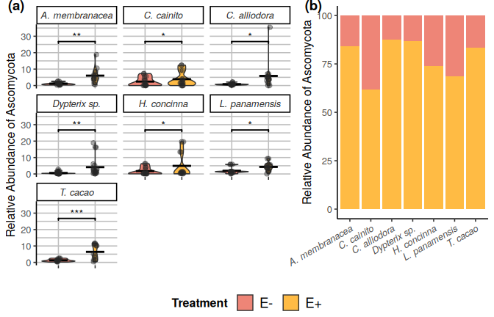

Relative abundance (RA) of Ascomycota OTUs of seven tree species used in the study. (a) Violin plots show individuals’ RA and and its distribution by species. The horizontal line within the violins represents the mean RA per species. (b) The RA of OTU’s by treatment withing each tree species. Pink filled violin plots represent low endophyte (*E-*) treatment and yellow filled represent high endophyte (*E+*) treatment. Relative abundance is the percentage of endophyte colonization within individuals of the same species. Significance levels are represented by ns (not significant) and asterisks [p < 0.05 (*), p < 0.01 (**), p < 0.001 (***), and p < 0.0001 (****)].

## 13.2 Figure 2

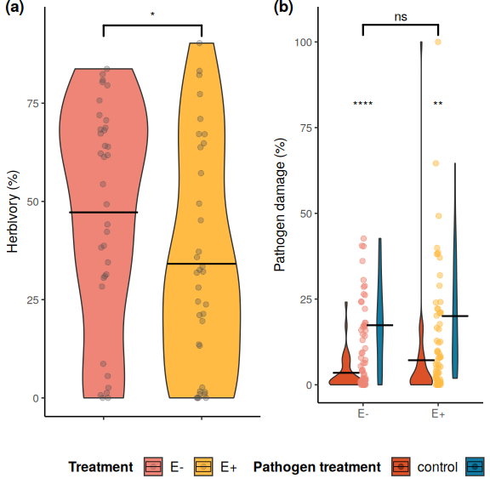

Distributions of values and means of herbivory (%) damage caused by *Atta colombica* in treatment groups (*E-* and *E+*) and tree species. a) Comparison of herbivory (%) means between treatment groups across individuals of all species. Pink filled violins represent low FEF group (*E-*) and yellow filed violins represent high FEF group (*E+*). b) Comparison of pathogen (%) means between treatment groups across individuals of all species. Maroon filled violins represent control leaves and blue filled violins represent pathogen treated leaves. Statistical significance was calculated using a two-sided Student’s t-Test. Significance levels are represented by ns (not significant) and asterisks [p < 0.05 (*), p < 0.01 (**), p < 0.001 (***), and p < 0.0001 (****)].

## 13.3 Figure 3

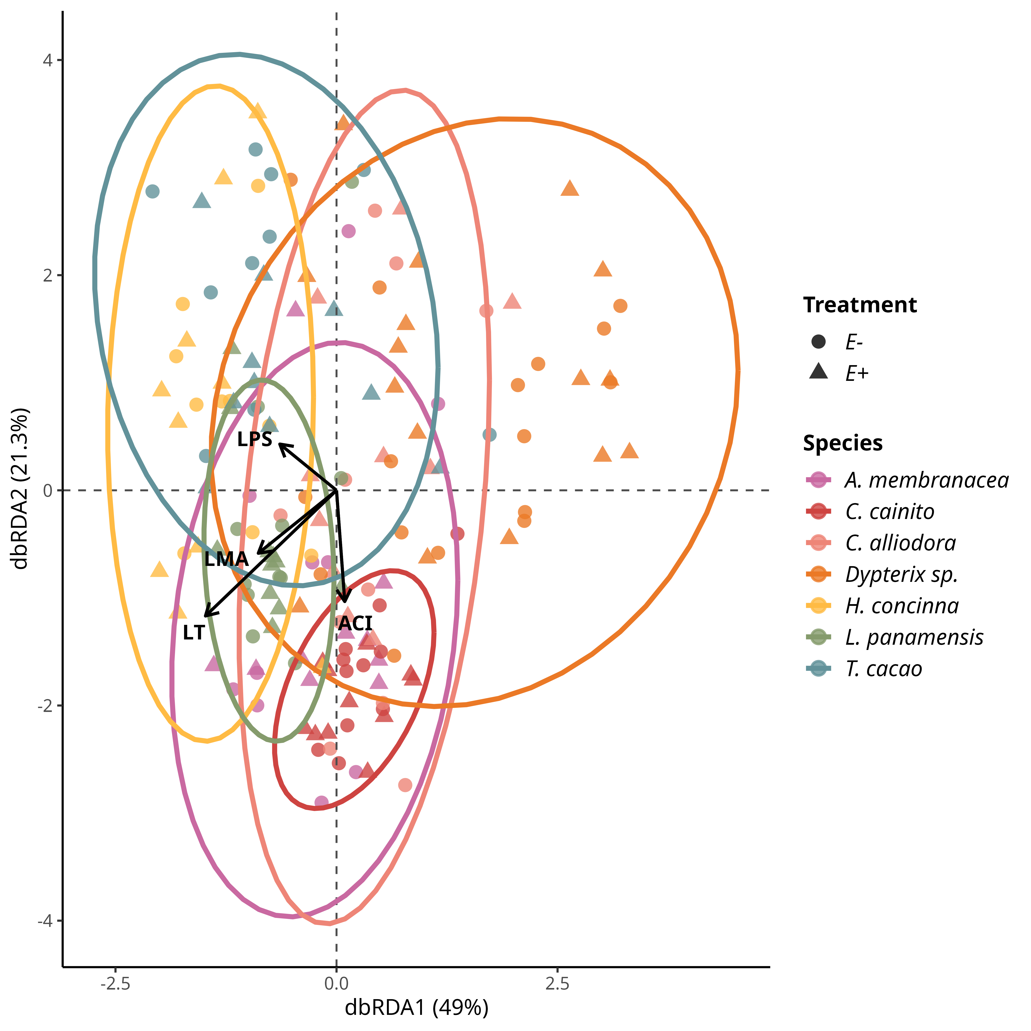

FEF community composition was associated with leaf functional traits from the leaf economic spectrum (genomic data set). variation in FEF community composition within and between host species (*n* = 7) and treatment groups (*E*-, *E*+) from distanmce-based redundancy analyses (dbRDA). Solid arrows represent statistically sisgnificant associations (*p* < 0.05). Each point represent a FEF community samples from one host tree species per treatment group; colors represent host tree species. Circles and filled triangles represent low (*E*-) and high (*E*+) FEF treatment groups, respectively.

## 13.4 Figure 4



Leaf Functional traits are conserved within tree species regardless of endophyte load treatment. (a) Principal Component Analysis (PCA) of leaf functional traits from all tree species separated by *E-* and *E+* treatment. (b) PCA of leaf functional traits of plants solely used in ant herbivory assays. (c) PCA leaf functional traits of plants used solely in pathogen damage assays. Colors represent tree species. Circle and triangles represent low (*E-*) and high (*E+*) FEF treatment groups, respectively. Colored ellipses correspond to tree species and represent 95% confidence intervals.

## 13.5 Figure 5

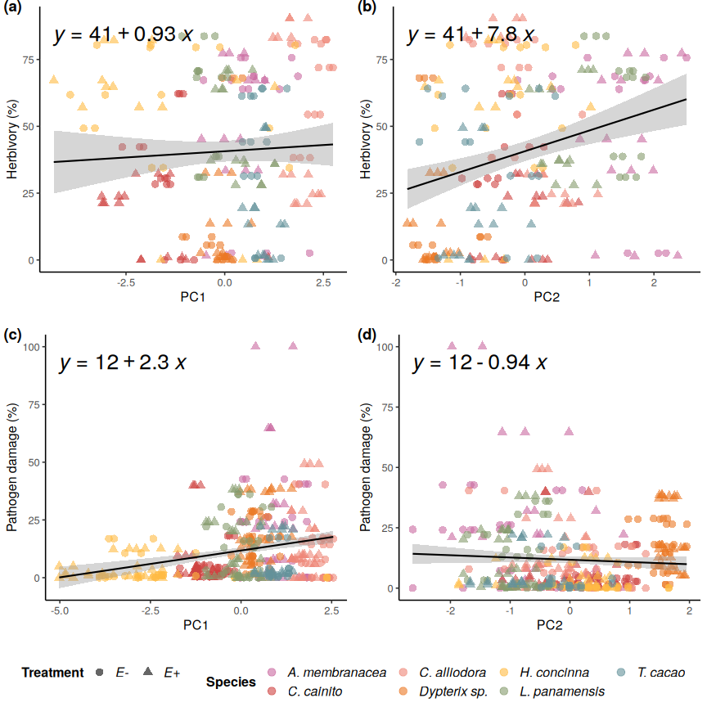

Simple linear regressions of herbivory and pathogen damage on PC1 and PC2 axes from PCAs of leaf traits for ant herbivory and pathogen damage assays. Linear regression of a) percent herbivory damage and PC1 axis (R2-adjusted= -0.0024, *p* = 0.447); b) percent herbivory damage and PC2 axis (R2-adjusted = 0.079, *p* = <0.001); c) percent pathogen damage and PC1 axis (R2-adjusted = 0.064, *p* = <0.001); and d) percent pathogen damage and PC2 axis (R2-adjusted = 0.0016, *p* = 0.207). Colors represent individual species. Circle and triangles represent *E-* and *E+* treatments, respectively.

# 14. Tables

## 14.1 Table 1

**Table 1:** **Replication statement of the statistical analysis in this study.**

|  |  |  |
| --- | --- | --- |
| **Scale of inference** | **Scale at which the factor of interest is applied** | **Number of replicates at the appropriate scale** |
| Leaf functional traits | Species | Treatment = 2 (E-, E+), Tropical tree species = 7, Replicates per species = 5. Replicate leaves per plant = 3 |
| Genomic data | Species | Treatment = 2 (E-, E+), Tropical tree species = 7, Replicates per species = 5 |
| Herbivore assays | Species/individual | Treatment = 2 (E-, E+), Tropical tree species = 7, Replicates per species = 5, Replicates per plant = 1 |
| Pathogen assays | Species/individual | Treatment = 2 (E-, E+), sub-treatment = 2 (control and pathogen) for pathogen trials, Tropical tree species = 7, Replicates per species = 5, Replicates per plant = 1 |

## 14.2 Table 2

**Table 2: Summary statistics for the leaf functional traits**

|  | ***A. membranacea, n = 831*** | ***C. alliodora, n = 1001*** | ***C. cainito, n = 1501*** | ***Dypterix sp., n = 2881*** | ***H. concinna, n = 1321*** | ***L. panamensis, n = 1851*** | ***T. cacao, n = 1761*** |
| --- | --- | --- | --- | --- | --- | --- | --- |
| *Treatment* |  |  |  |  |  |  |  |
| E- (n = 570) | 47 | 54 | 75 | 144 | 66 | 95 | 89 |
| E+ (n = 544) | 36 | 46 | 75 | 144 | 66 | 90 | 87 |
| Anthocyanins (ACI) | 5.35 ± 1.06 | 3.47 ± 0.43 | 8.21 ± 1.41 | 6.34 ± 1.15 | 6.77 ± 2.86 | 5.91 ± 1.30 | 4.18 ± 0.77 |
| Leaf Thickness (LT) (µm) | 270 ± 45 | 207 ± 37 | 205 ± 30 | 148 ± 13 | 214 ± 42 | 245 ± 18 | 200 ± 43 |
| Leaf Punch Strength (LPS) (N mm/1) | 0.22 ± 0.05 | 0.21 ± 0.05 | 0.53 ± 0.09 | 0.43 ± 0.06 | 0.77 ± 0.23 | 0.33 ± 0.04 | 0.38 ± 0.06 |
| Leaf Mass per Area (LMA) (mg/mm) | 0.0011 ± 0.0002 | 0.0007 ± 0.0001 | 0.0015 ± 0.0002 | 0.0011 ± 0.0001 | 0.0017 ± 0.0004 | 0.0014 ± 0.0002 | 0.0009 ± 0.0001 |
| 1n = observations ; Mean ± SD | | | | | | | |

## 14.3 Table 3

**Table 3: Generalized linear mixed models (GLMMs) for predicting leaf herbivory and pathogen damage**

|  |  |  |  |  |
| --- | --- | --- | --- | --- |
|  | **Herbivory model** | | **Pathogen damage model** | |
| **Predictors** | **Estimate** | **CI [t-statistic]** | **Estimate** | **CI [t-statistic]** |
| ***Fixed effects*** |  |  |  |  |
| Intercept | -0.257 | (-2.315 - 1.801 ) [-0.246] | **-3.416 \*\*\*** | **(-4.403 - -2.428 ) [-6.801]** |
| Thickness | **-0.010 \*** | **(-0.018 - -0.002 ) [-2.517]** | 0.003 | (-0.001 - 0.007 ) [1.666] |
| LMA | **1741.216 \*\*\*** | **(768.816 - 2713.616 ) [3.531]** | 171.649 | (-181.400 - 524.698 ) [0.956] |
| Endophyte load (E+) | **-0.777 \*\*\*** | **(-1.109 - -0.445 ) [-4.619]** |  |  |
| ***Random effects*** |  |  |  |  |
| Intercept | 1.390 | (0.753 - 2.565 ) |  |  |
| Observations | 1.827 |  |  |  |
| *A. membranacea* | 1.000 |  | 1.000 |  |
| *C. cainito* | 0.654 |  | 0.780 |  |
| *C. alliodora* | 0.600 |  | 0.463 |  |
| *Dypterix sp.* | 0.784 |  | 0.513 |  |
| *H. concinna* | 0.822 |  | 0.365 |  |
| *L. panamensis* | 0.425 |  | 0.312 |  |
| *T. cacao* | 0.782 |  | 0.767 |  |
| N | 210 |  | 382 |  |
| logLik | -358.893 |  | -492.620 |  |
| AIC | 741.785 |  | 1011.239 |  |
| Significance levels are represented by asterisks [p < 0.05 (*), p <= 0.01 (**), p <= 0.001 (***), and p < 0.0001 (****)]. T statistics in brackets. | | | | |

# 15. Supplementary Materials

## 15.1 Table S1

| **Table S1: Student's t-Tests of mean anthocyanins (ACI)**  Pairwise comparisons of ACI between species. | | | | |
| --- | --- | --- | --- | --- |
|  | *p* - values | | | |
| Comparison Species*1* | p | p.adj | p.format | p.signif*2* |
| ***A. membranacea*** | | | | |
| *C. cainito* | **2.636 × 10^-16** | **4.500 × 10^-15** | **2.6e-16** | **\*\*\*\*** |
| *C. alliodora* | **3.713 × 10^-15** | **5.600 × 10^-14** | **3.7e-15** | **\*\*\*\*** |
| *Dypterix* sp. | **2.296 × 10^-6** | **1.600 × 10^-5** | **2.3e-06** | **\*\*\*\*** |
| *H. concinna* | **6.179 × 10^-6** | **3.700 × 10^-5** | **6.2e-06** | **\*\*\*\*** |
| *L. panamensis* | **1.538 × 10^-2** | **4.600 × 10^-2** | **0.01538** | **\*** |
| *T. cacao* | **9.137 × 10^-8** | **8.200 × 10^-7** | **9.1e-08** | **\*\*\*\*** |
| ***C. cainito*** | | | | |
| *C. alliodora* | **3.154 × 10^-23** | **6.300 × 10^-22** | **< 2e-16** | **\*\*\*\*** |
| *Dypterix* sp. | **4.559 × 10^-10** | **5.000 × 10^-9** | **4.6e-10** | **\*\*\*\*** |
| *H. concinna* | 5.309 × 10^-1 | 5.300 × 10^-1 | 0.53085 | ns |
| *L. panamensis* | **1.599 × 10^-11** | **2.200 × 10^-10** | **1.6e-11** | **\*\*\*\*** |
| *T. cacao* | **3.656 × 10^-22** | **6.900 × 10^-21** | **< 2e-16** | **\*\*\*\*** |
| ***C. alliodora*** | | | | |
| *Dypterix* sp. | **1.150 × 10^-26** | **2.400 × 10^-25** | **< 2e-16** | **\*\*\*\*** |
| *H. concinna* | **7.276 × 10^-11** | **9.500 × 10^-10** | **7.3e-11** | **\*\*\*\*** |
| *L. panamensis* | **2.486 × 10^-15** | **4.000 × 10^-14** | **2.5e-15** | **\*\*\*\*** |
| *T. cacao* | **1.428 × 10^-7** | **1.100 × 10^-6** | **1.4e-07** | **\*\*\*\*** |
| ***Dypterix* sp.** | | | | |
| *H. concinna* | **3.050 × 10^-3** | **1.200 × 10^-2** | **0.00305** | **\*\*** |
| *L. panamensis* | 6.646 × 10^-2 | 1.300 × 10^-1 | 0.06646 | ns |
| *T. cacao* | **3.807 × 10^-18** | **6.900 × 10^-17** | **< 2e-16** | **\*\*\*\*** |
| ***H. concinna*** | | | | |
| *L. panamensis* | **3.062 × 10^-4** | **1.500 × 10^-3** | **0.00031** | **\*\*\*** |
| *T. cacao* | **5.704 × 10^-9** | **5.700 × 10^-8** | **5.7e-09** | **\*\*\*\*** |
| ***L. panamensis*** | | | | |
| *T. cacao* | **3.583 × 10^-10** | **4.300 × 10^-9** | **3.6e-10** | **\*\*\*\*** |
| *1* *n* = 156 individuals | | | | |
| *2*Significance levels are represented by *ns* (not significant) and asterisks [*p* = 0.05 (*), *p* = 0.01 (**), *p* = 0.001 (***), and *p* < 0.0001 (****)]. | | | | |

## 15.2 Table S2

| **Table S2: Student's t-Tests of mean leaf thickness (LT) (μm)**  Pairwise comparisons of LT between species. | | | | |
| --- | --- | --- | --- | --- |
|  | *p* - values | | | |
| Comparison Species*1* | p | p.adj | p.format | p.signif*2* |
| ***A. membranacea*** | | | | |
| *C. cainito* | **1.793 × 10^-8** | **2.300 × 10^-7** | **1.8e-08** | **\*\*\*\*** |
| *C. alliodora* | **6.857 × 10^-8** | **8.200 × 10^-7** | **6.9e-08** | **\*\*\*\*** |
| *Dypterix* sp. | **7.836 × 10^-18** | **1.500 × 10^-16** | **< 2e-16** | **\*\*\*\*** |
| *H. concinna* | **1.255 × 10^-5** | **1.000 × 10^-4** | **1.3e-05** | **\*\*\*\*** |
| *L. panamensis* | 4.986 × 10^-1 | 1.000 | 0.499 | ns |
| *T. cacao* | **1.604 × 10^-6** | **1.400 × 10^-5** | **1.6e-06** | **\*\*\*\*** |
| ***C. cainito*** | | | | |
| *C. alliodora* | 7.854 × 10^-1 | 1.000 | 0.785 | ns |
| *Dypterix* sp. | **2.605 × 10^-19** | **5.200 × 10^-18** | **< 2e-16** | **\*\*\*\*** |
| *H. concinna* | 6.876 × 10^-2 | 4.800 × 10^-1 | 0.069 | ns |
| *L. panamensis* | **1.382 × 10^-12** | **2.100 × 10^-11** | **1.4e-12** | **\*\*\*\*** |
| *T. cacao* | 4.765 × 10^-1 | 1.000 | 0.477 | ns |
| ***C. alliodora*** | | | | |
| *Dypterix* sp. | **8.662 × 10^-17** | **1.500 × 10^-15** | **< 2e-16** | **\*\*\*\*** |
| *H. concinna* | 1.347 × 10^-1 | 8.100 × 10^-1 | 0.135 | ns |
| *L. panamensis* | **1.161 × 10^-10** | **1.600 × 10^-9** | **1.2e-10** | **\*\*\*\*** |
| *T. cacao* | 6.481 × 10^-1 | 1.000 | 0.648 | ns |
| ***Dypterix* sp.** | | | | |
| *H. concinna* | **8.177 × 10^-17** | **1.500 × 10^-15** | **< 2e-16** | **\*\*\*\*** |
| *L. panamensis* | **8.008 × 10^-32** | **1.700 × 10^-30** | **< 2e-16** | **\*\*\*\*** |
| *T. cacao* | **4.639 × 10^-13** | **7.400 × 10^-12** | **4.6e-13** | **\*\*\*\*** |
| ***H. concinna*** | | | | |
| *L. panamensis* | **7.274 × 10^-7** | **7.300 × 10^-6** | **7.3e-07** | **\*\*\*\*** |
| *T. cacao* | 3.649 × 10^-1 | 1.000 | 0.365 | ns |
| ***L. panamensis*** | | | | |
| *T. cacao* | **1.707 × 10^-7** | **1.900 × 10^-6** | **1.7e-07** | **\*\*\*\*** |
| *1* *n* = 156 individuals | | | | |
| *2*Significance levels are represented by *ns* (not significant) and asterisks [*p* = 0.05 (*), *p* = 0.01 (**), *p* = 0.001 (***), and *p* < 0.0001 (****)]. | | | | |

## 15.3 Table S3

| **Table S3: Student's t-Tests of mean leaf punch strength (LPS) (N mm-1)**  Pairwise comparisons of LPS between species. | | | | |
| --- | --- | --- | --- | --- |
|  | *p* - values | | | |
| Comparison Species*1* | p | p.adj | p.format | p.signif*2* |
| ***A. membranacea*** | | | | |
| *C. cainito* | **9.032 × 10^-36** | **1.600 × 10^-34** | **< 2e-16** | **\*\*\*\*** |
| *C. alliodora* | 3.180 × 10^-1 | 3.200 × 10^-1 | 0.32 | ns |
| *Dypterix* sp. | **3.538 × 10^-43** | **7.400 × 10^-42** | **< 2e-16** | **\*\*\*\*** |
| *H. concinna* | **7.548 × 10^-21** | **8.700 × 10^-20** | **< 2e-16** | **\*\*\*\*** |
| *L. panamensis* | **7.304 × 10^-26** | **1.200 × 10^-24** | **< 2e-16** | **\*\*\*\*** |
| *T. cacao* | **7.242 × 10^-21** | **8.700 × 10^-20** | **< 2e-16** | **\*\*\*\*** |
| ***C. cainito*** | | | | |
| *C. alliodora* | **3.873 × 10^-39** | **7.700 × 10^-38** | **< 2e-16** | **\*\*\*\*** |
| *Dypterix* sp. | **3.649 × 10^-16** | **2.200 × 10^-15** | **3.6e-16** | **\*\*\*\*** |
| *H. concinna* | **6.101 × 10^-12** | **2.400 × 10^-11** | **6.1e-12** | **\*\*\*\*** |
| *L. panamensis* | **3.975 × 10^-28** | **6.800 × 10^-27** | **< 2e-16** | **\*\*\*\*** |
| *T. cacao* | **7.651 × 10^-21** | **8.700 × 10^-20** | **< 2e-16** | **\*\*\*\*** |
| ***C. alliodora*** | | | | |
| *Dypterix* sp. | **1.738 × 10^-36** | **3.300 × 10^-35** | **< 2e-16** | **\*\*\*\*** |
| *H. concinna* | **1.267 × 10^-21** | **1.600 × 10^-20** | **< 2e-16** | **\*\*\*\*** |
| *L. panamensis* | **8.205 × 10^-21** | **8.700 × 10^-20** | **< 2e-16** | **\*\*\*\*** |
| *T. cacao* | **1.371 × 10^-22** | **1.900 × 10^-21** | **< 2e-16** | **\*\*\*\*** |
| ***Dypterix* sp.** | | | | |
| *H. concinna* | **1.617 × 10^-15** | **8.100 × 10^-15** | **1.6e-15** | **\*\*\*\*** |
| *L. panamensis* | **7.768 × 10^-26** | **1.200 × 10^-24** | **< 2e-16** | **\*\*\*\*** |
| *T. cacao* | **3.965 × 10^-7** | **8.800 × 10^-7** | **4.0e-07** | **\*\*\*\*** |
| ***H. concinna*** | | | | |
| *L. panamensis* | **2.293 × 10^-18** | **1.800 × 10^-17** | **< 2e-16** | **\*\*\*\*** |
| *T. cacao* | **1.173 × 10^-17** | **8.200 × 10^-17** | **< 2e-16** | **\*\*\*\*** |
| ***L. panamensis*** | | | | |
| *T. cacao* | **2.949 × 10^-7** | **8.800 × 10^-7** | **2.9e-07** | **\*\*\*\*** |
| *1* *n* = 156 individuals | | | | |
| *2*Significance levels are represented by *ns* (not significant) and asterisks [*p* = 0.05 (*), *p* = 0.01 (**), *p* = 0.001 (***), and *p* < 0.0001 (****)]. | | | | |

## 15.4 Table S4

| **Table S4:** **Student's t-Tests of mean leaf mass per area (LMA) (mg mm-2)**  Pairwise comparisons of LMA between species. | | | | |
| --- | --- | --- | --- | --- |
|  | *p* - values | | | |
| Comparison Species*1* | p | p.adj | p.format | p.signif*2* |
| ***A. membranacea*** | | | | |
| *C. cainito* | **9.032 × 10^-36** | **1.600 × 10^-34** | **< 2e-16** | **\*\*\*\*** |
| *C. alliodora* | 3.180 × 10^-1 | 3.200 × 10^-1 | 0.32 | ns |
| *Dypterix* sp. | **3.538 × 10^-43** | **7.400 × 10^-42** | **< 2e-16** | **\*\*\*\*** |
| *H. concinna* | **7.548 × 10^-21** | **8.700 × 10^-20** | **< 2e-16** | **\*\*\*\*** |
| *L. panamensis* | **7.304 × 10^-26** | **1.200 × 10^-24** | **< 2e-16** | **\*\*\*\*** |
| *T. cacao* | **7.242 × 10^-21** | **8.700 × 10^-20** | **< 2e-16** | **\*\*\*\*** |
| ***C. cainito*** | | | | |
| *C. alliodora* | **3.873 × 10^-39** | **7.700 × 10^-38** | **< 2e-16** | **\*\*\*\*** |
| *Dypterix* sp. | **3.649 × 10^-16** | **2.200 × 10^-15** | **3.6e-16** | **\*\*\*\*** |
| *H. concinna* | **6.101 × 10^-12** | **2.400 × 10^-11** | **6.1e-12** | **\*\*\*\*** |
| *L. panamensis* | **3.975 × 10^-28** | **6.800 × 10^-27** | **< 2e-16** | **\*\*\*\*** |
| *T. cacao* | **7.651 × 10^-21** | **8.700 × 10^-20** | **< 2e-16** | **\*\*\*\*** |
| ***C. alliodora*** | | | | |
| *Dypterix* sp. | **1.738 × 10^-36** | **3.300 × 10^-35** | **< 2e-16** | **\*\*\*\*** |
| *H. concinna* | **1.267 × 10^-21** | **1.600 × 10^-20** | **< 2e-16** | **\*\*\*\*** |
| *L. panamensis* | **8.205 × 10^-21** | **8.700 × 10^-20** | **< 2e-16** | **\*\*\*\*** |
| *T. cacao* | **1.371 × 10^-22** | **1.900 × 10^-21** | **< 2e-16** | **\*\*\*\*** |
| ***Dypterix* sp.** | | | | |
| *H. concinna* | **1.617 × 10^-15** | **8.100 × 10^-15** | **1.6e-15** | **\*\*\*\*** |
| *L. panamensis* | **7.768 × 10^-26** | **1.200 × 10^-24** | **< 2e-16** | **\*\*\*\*** |
| *T. cacao* | **3.965 × 10^-7** | **8.800 × 10^-7** | **4.0e-07** | **\*\*\*\*** |
| ***H. concinna*** | | | | |
| *L. panamensis* | **2.293 × 10^-18** | **1.800 × 10^-17** | **< 2e-16** | **\*\*\*\*** |
| *T. cacao* | **1.173 × 10^-17** | **8.200 × 10^-17** | **< 2e-16** | **\*\*\*\*** |
| ***L. panamensis*** | | | | |
| *T. cacao* | **2.949 × 10^-7** | **8.800 × 10^-7** | **2.9e-07** | **\*\*\*\*** |
| *1* *n* = 156 individuals | | | | |
| *2*Significance levels are represented by *ns* (not significant) and asterisks [*p* = 0.05 (*), *p* = 0.01 (**), *p* = 0.001 (***), and *p* < 0.0001 (****)]. | | | | |

## 15.5 Table S5

| **Table S5: Taxonomy of OTUs significantly correlated OTUs with tree host species.** | | | | | | | | | | | |
| --- | --- | --- | --- | --- | --- | --- | --- | --- | --- | --- | --- |
|  |  |  |  |  |  |  |  | Multilevel pattern analysis | | | |
| Kingdom | Phylum | Class | Order | Family | Genus | Species | OTU | Index | Stat | *p1* | *p*adj*2* |
| ***T. cacao*** | | | | | | | | | | | |
| Fungi | Ascomycota | Dothideomycetes | Capnodiales | Mycosphaerellaceae | Coremiopassalora | *Coremiopassalora leptophlebae* | OTU 2 | 7 | 0.507 | ** | 0.012 |
| Fungi | Ascomycota | Dothideomycetes | Capnodiales | Mycosphaerellaceae | Pseudocercospora | *Pseudocercospora sp* | OTU 5 | 7 | 0.531 | ** | 0.012 |
| Fungi | Ascomycota | Eurotiomycetes | Eurotiales | Trichocomaceae | Talaromyces | *Talaromyces sp* | OTU 3 | 7 | 0.469 | ** | 0.012 |
| Fungi | Ascomycota | unidentified | unidentified | unidentified | unidentified | *Ascomycota sp* | OTU 14 | 7 | 0.500 | ** | 0.012 |
| Fungi | Ascomycota | Dothideomycetes | Capnodiales | Cladosporiaceae | Cladosporium | *Cladosporium sp* | OTU 20 | 7 | 0.382 | ** | 0.012 |
| Fungi | Ascomycota | Dothideomycetes | Capnodiales | Mycosphaerellaceae | Zasmidium | *Zasmidium queenslandicum* | OTU 95 | 7 | 0.390 | ** | 0.012 |
| Fungi | Ascomycota | Sordariomycetes | Hypocreales | Hypocreales_fam_Incertae_sedis | Acremonium | *Acremonium sp* | OTU 84 | 7 | 0.430 | ** | 0.012 |
| Fungi | Ascomycota | Dothideomycetes | Capnodiales | Dissoconiaceae | Ramichloridium | *Ramichloridium sp* | OTU 79 | 7 | 0.362 | ** | 0.019 |
| Fungi | Ascomycota | Dothideomycetes | Capnodiales | Mycosphaerellaceae | Mycosphaerella | *Mycosphaerella sp* | OTU 183 | 7 | 0.427 | ** | 0.012 |
| Fungi | Ascomycota | Sordariomycetes | Xylariales | Xylariaceae | Annulohypoxylon | *Annulohypoxylon urceolatum* | OTU 279 | 7 | 0.352 | ** | 0.019 |
| Fungi | Ascomycota | Dothideomycetes | Capnodiales | Mycosphaerellaceae | Zasmidium | *Zasmidium commune* | OTU 286 | 7 | 0.331 | ** | 0.041 |
| ***H. concinna*** | | | | | | | | | | | |
| Fungi | Ascomycota | Sordariomycetes | Hypocreales | Nectriaceae | Fusarium | *Fusarium sp* | OTU 7 | 5 | 0.330 | ** | 0.012 |
| Fungi | Ascomycota | Eurotiomycetes | Chaetothyriales | Herpotrichiellaceae | Exophiala | *Exophiala oligosperma* | OTU 21 | 5 | 0.220 | ** | 0.012 |
| Fungi | Ascomycota | Sordariomycetes | Hypocreales | Clavicipitaceae | unidentified | *Clavicipitaceae sp* | OTU 53 | 5 | 0.281 | ** | 0.012 |
| Fungi | Ascomycota | Saccharomycetes | Saccharomycetales | Saccharomycetales_fam_Incertae_sedis | Candida | *Candida parapsilosis* | OTU 67 | 5 | 0.272 | ** | 0.027 |
| Fungi | Ascomycota | Eurotiomycetes | Chaetothyriales | Trichomeriaceae | Bradymyces | *Bradymyces sp* | OTU 160 | 5 | 0.251 | ** | 0.047 |
| Fungi | Ascomycota | Eurotiomycetes | Chaetothyriales | Herpotrichiellaceae | Exophiala | *Exophiala oligosperma* | OTU 173 | 5 | 0.350 | ** | 0.012 |
| Fungi | Ascomycota | Sordariomycetes | Sordariales | Chaetomiaceae | unidentified | *Chaetomiaceae sp* | OTU 209 | 5 | 0.351 | ** | 0.019 |
| Fungi | Ascomycota | Dothideomycetes | Pleosporales | Didymellaceae | Neodidymelliopsis | *Neodidymelliopsis sambuci* | OTU 596 | 5 | 0.351 | ** | 0.019 |
| ***Dypterix sp.*** | | | | | | | | | | | |
| Fungi | Ascomycota | Dothideomycetes | Capnodiales | Dissoconiaceae | Uwebraunia | *Uwebraunia dekkeri* | OTU 12 | 4 | 0.418 | ** | 0.012 |
| Fungi | Ascomycota | Eurotiomycetes | Eurotiales | Aspergillaceae | Aspergillus | *Aspergillus sp* | OTU 122 | 4 | 0.257 | ** | 0.047 |
| Fungi | Ascomycota | Dothideomycetes | Capnodiales | Dissoconiaceae | Ramichloridium | *Ramichloridium punctatum* | OTU 151 | 4 | 0.378 | ** | 0.012 |
| Fungi | Ascomycota | Sordariomycetes | Xylariales | Xylariaceae | unidentified | *Xylariaceae sp* | OTU 216 | 4 | 0.390 | ** | 0.019 |
| Fungi | Ascomycota | Dothideomycetes | Capnodiales | Schizothyriaceae | Zygophiala | *Zygophiala qianensis* | OTU 305 | 4 | 0.333 | ** | 0.034 |
| ***A. membranacea*** | | | | | | | | | | | |
| Fungi | Ascomycota | Sordariomycetes | Xylariales | unidentified | unidentified | *Xylariales sp* | OTU 25 | 1 | 0.219 | ** | 0.012 |
| Fungi | Ascomycota | Dothideomycetes | Capnodiales | Mycosphaerellaceae | Septoria | *Septoria sp* | OTU 26 | 1 | 0.366 | ** | 0.012 |
| Fungi | Ascomycota | Sordariomycetes | Xylariales | Xylariaceae | Xylaria | *Xylaria curta* | OTU 172 | 9 | 0.413 | ** | 0.012 |
| Fungi | Ascomycota | Dothideomycetes | Pleosporales | Pleosporaceae | Curvularia | *Curvularia sp* | OTU 120 | 1 | 0.352 | ** | 0.047 |
| ***C. alliodora*** | | | | | | | | | | | |
| Fungi | Ascomycota | Dothideomycetes | Botryosphaeriales | Phyllostictaceae | Phyllosticta | *Phyllosticta capitalensis* | OTU 32 | 19 | 0.362 | ** | 0.012 |
| Fungi | Ascomycota | Sordariomycetes | Diaporthales | Diaporthaceae | Diaporthe | *Diaporthe longicolla* | OTU 31 | 3 | 0.531 | ** | 0.012 |
| Fungi | Ascomycota | Sordariomycetes | Glomerellales | Glomerellaceae | Colletotrichum | *Colletotrichum gigasporum* | OTU 34 | 3 | 0.374 | ** | 0.012 |
| Fungi | Ascomycota | Sordariomycetes | Xylariales | Xylariaceae | Xylaria | *Xylaria sp* | OTU 62 | 3 | 0.516 | ** | 0.012 |
| Fungi | Ascomycota | unidentified | unidentified | unidentified | unidentified | *Ascomycota sp* | OTU 52 | 3 | 0.494 | ** | 0.012 |
| Fungi | Ascomycota | Sordariomycetes | Diaporthales | Diaporthaceae | Diaporthe | *Diaporthe sp* | OTU 99 | 3 | 0.443 | ** | 0.012 |
| Fungi | Ascomycota | Sordariomycetes | Sordariales | Chaetomiaceae | Ovatospora | *Ovatospora brasiliensis* | OTU 61 | 3 | 0.374 | ** | 0.012 |
| Fungi | Ascomycota | Dothideomycetes | Pleosporales | Phaeosphaeriaceae | Setophoma | *Setophoma sp* | OTU 71 | 3 | 0.386 | ** | 0.012 |
| Fungi | Ascomycota | Sordariomycetes | Xylariales | Xylariaceae | Annulohypoxylon | *Annulohypoxylon stygium* | OTU 78 | 3 | 0.503 | ** | 0.012 |
| Fungi | Ascomycota | Sordariomycetes | Xylariales | Xylariaceae | Hypoxylon | *Hypoxylon sp* | OTU 101 | 3 | 0.483 | ** | 0.012 |
| Fungi | Ascomycota | Sordariomycetes | Diaporthales | Diaporthaceae | Diaporthe | *Diaporthe sp* | OTU 223 | 3 | 0.415 | ** | 0.012 |
| Fungi | Ascomycota | Sordariomycetes | Xylariales | Xylariaceae | Xylaria | *Xylaria sp* | OTU 212 | 3 | 0.501 | ** | 0.012 |
| Fungi | Ascomycota | Dothideomycetes | Capnodiales | Cladosporiaceae | Melomastia | *Melomastia sp* | OTU 117 | 3 | 0.429 | ** | 0.012 |
| Fungi | Ascomycota | Dothideomycetes | Pleosporales | Morosphaeriaceae | Acrocalymma | *Acrocalymma sp* | OTU 169 | 3 | 0.434 | ** | 0.012 |
| Fungi | Ascomycota | Sordariomycetes | Diaporthales | Diaporthaceae | Diaporthe | *Diaporthe sp* | OTU 512 | 3 | 0.461 | ** | 0.012 |
| Fungi | Ascomycota | Sordariomycetes | Diaporthales | Diaporthaceae | Diaporthe | *Diaporthe melonis* | OTU 179 | 3 | 0.475 | ** | 0.012 |
| Fungi | Ascomycota | Sordariomycetes | Xylariales | Xylariales_fam_Incertae_sedis | Oxydothis | *Oxydothis garethjonesii* | OTU 94 | 57 | 0.366 | ** | 0.027 |
| Fungi | Ascomycota | Sordariomycetes | Xylariales | Xylariaceae | unidentified | *Xylariaceae sp* | OTU 106 | 3 | 0.455 | ** | 0.012 |
| Fungi | Ascomycota | Sordariomycetes | Xylariales | Xylariaceae | Hypoxylon | *Hypoxylon hypomiltum* | OTU 142 | 3 | 0.369 | ** | 0.012 |
| Fungi | Ascomycota | Sordariomycetes | Xylariales | Xylariaceae | Xylaria | *Xylaria sp* | OTU 262 | 3 | 0.399 | ** | 0.012 |
| Fungi | Ascomycota | Sordariomycetes | Diaporthales | Diaporthaceae | Diaporthe | *Diaporthe sp* | OTU 327 | 3 | 0.480 | ** | 0.012 |
| Fungi | Ascomycota | Sordariomycetes | Xylariales | Xylariaceae | Hypoxylon | *Hypoxylon submonticulosum* | OTU 202 | 3 | 0.339 | ** | 0.012 |
| Fungi | Ascomycota | Sordariomycetes | Xylariales | Amphisphaeriaceae | Lepteutypa | *Lepteutypa sambuci* | OTU 210 | 3 | 0.410 | ** | 0.012 |
| Fungi | Ascomycota | Sordariomycetes | Xylariales | Xylariaceae | unidentified | *Xylariaceae sp* | OTU 380 | 3 | 0.351 | ** | 0.019 |
| Fungi | Ascomycota | Sordariomycetes | Xylariales | Xylariaceae | unidentified | *Xylariaceae sp* | OTU 537 | 3 | 0.451 | ** | 0.012 |
| Fungi | Ascomycota | Sordariomycetes | Sordariales | Lasiosphaeriaceae | unidentified | *Lasiosphaeriaceae sp* | OTU 219 | 3 | 0.349 | ** | 0.019 |
| Fungi | Ascomycota | unidentified | unidentified | unidentified | unidentified | *Ascomycota sp* | OTU 192 | 3 | 0.395 | ** | 0.012 |
| Fungi | Ascomycota | Sordariomycetes | Xylariales | Xylariaceae | Lopadostoma | *Lopadostoma americanum* | OTU 936 | 3 | 0.417 | ** | 0.019 |
| Fungi | Ascomycota | Sordariomycetes | Sordariales | Sordariales_fam_Incertae_sedis | Ramophialophora | *Ramophialophora sp* | OTU 362 | 3 | 0.330 | ** | 0.041 |
| Fungi | Ascomycota | unidentified | unidentified | unidentified | unidentified | *Ascomycota sp* | OTU 784 | 3 | 0.399 | ** | 0.012 |
| Fungi | Ascomycota | Sordariomycetes | unidentified | unidentified | unidentified | *Sordariomycetes sp* | OTU 397 | 3 | 0.435 | ** | 0.019 |
| Fungi | Ascomycota | Sordariomycetes | Diaporthales | Diaporthaceae | Diaporthe | *Diaporthe fraxini-angustifoliae* | OTU 575 | 3 | 0.379 | ** | 0.019 |
| Fungi | Ascomycota | Sordariomycetes | Glomerellales | Glomerellaceae | Colletotrichum | *Colletotrichum ignotum* | OTU 614 | 3 | 0.342 | ** | 0.034 |
| ***C. cainito*** | | | | | | | | | | | |
| Fungi | Ascomycota | Sordariomycetes | Xylariales | unidentified | unidentified | *Xylariales sp* | OTU 58 | 2 | 0.362 | ** | 0.027 |
| Fungi | Ascomycota | Sordariomycetes | Hypocreales | Hypocreales_fam_Incertae_sedis | Sarocladium | *Sarocladium gamsii* | OTU 75 | 18 | 0.335 | ** | 0.012 |
| Fungi | Ascomycota | Sordariomycetes | Diaporthales | Valsaceae | Phomopsis | *Phomopsis sp* | OTU 86 | 2 | 0.323 | ** | 0.012 |
| Fungi | Ascomycota | Sordariomycetes | Sordariales | Cephalothecaceae | Phialemonium | *Phialemonium dimorphosporum* | OTU 139 | 2 | 0.334 | ** | 0.019 |
| Fungi | Ascomycota | Sordariomycetes | Hypocreales | Hypocreales_fam_Incertae_sedis | Acremonium | *Acremonium hennebertii* | OTU 145 | 2 | 0.406 | ** | 0.012 |
| Fungi | Ascomycota | Sordariomycetes | Xylariales | unidentified | unidentified | *Xylariales sp* | OTU 128 | 50 | 0.341 | ** | 0.041 |
| Fungi | Ascomycota | Arthoniomycetes | Lichenostigmatales | Phaeococcomycetaceae | Phaeococcomyces | *Phaeococcomyces rothmanniae* | OTU 197 | 2 | 0.352 | ** | 0.012 |
| Fungi | Ascomycota | Sordariomycetes | Diaporthales | Diaporthaceae | Diaporthe | *Diaporthe sp* | OTU 761 | 2 | 0.418 | ** | 0.012 |
| ***L. panamensis*** | | | | | | | | | | | |
| Fungi | Ascomycota | Sordariomycetes | Xylariales | Xylariales_fam_Incertae_sedis | Oxydothis | *Oxydothis sp* | OTU 221 | 6 | 0.335 | ** | 0.027 |
| Fungi | Ascomycota | Dothideomycetes | Pleosporales | unidentified | unidentified | *Pleosporales sp* | OTU 232 | 6 | 0.336 | ** | 0.027 |
| Fungi | Ascomycota | Sordariomycetes | Glomerellales | Glomerellales_fam_Incertae_sedis | Malaysiasca | *Malaysiasca phaii* | OTU 735 | 6 | 0.309 | ** | 0.019 |
| *1* Significance levels are represented by *ns* (not significant) and asterisks [*p* <= 0.05 (*), *p <*= 0.01 (**), *p <*= 0.001 (***), and *p* < 0.0001 (****)]. | | | | | | | | | | | |
| *2*Benjamini & Hochberg method adjustment for multiple comparisons | | | | | | | | | | | |

## 15.6 Table S6

| **Table S6: Taxonomy of significantly correlated OTUs with *Atta colombica* herbivory levels** | | | | | | | | | | | |
| --- | --- | --- | --- | --- | --- | --- | --- | --- | --- | --- | --- |
|  |  |  |  |  |  |  |  | Multilevel pattern analysis | | | |
| Kingdom | Phylum | Class | Order | Family | Genus | Species | OTU | Index | Stat | *p2* | *p*adj*3* |
| **Medium** | | | | | | | | | | | |
| Fungi | Ascomycota | Eurotiomycetes | Chaetothyriales | Cyphellophoraceae | Cyphellophora | *Cyphellophora oxyspora* | OTU 19 | 3 | 0.293 | * | 1.000 |
| Fungi | Ascomycota | unidentified | unidentified | unidentified | unidentified | *Ascomycota sp* | OTU 153 | 3 | 0.307 | * | 1.000 |
| Fungi | Ascomycota | Sordariomycetes | Hypocreales | unidentified | unidentified | *Hypocreales sp* | OTU 682 | 3 | 0.307 | * | 1.000 |
| **High** | | | | | | | | | | | |
| Fungi | Ascomycota | Sordariomycetes | Xylariales | Xylariaceae | Xylaria | *Xylaria sp* | OTU 62 | 1 | 0.315 | * | 1.000 |
| Fungi | Ascomycota | Eurotiomycetes | Eurotiales | Aspergillaceae | Aspergillus | *Aspergillus terreus* | OTU 55 | 1 | 0.232 | * | 1.000 |
| Fungi | Ascomycota | Sordariomycetes | Xylariales | Xylariaceae | Xylaria | *Xylaria sp* | OTU 212 | 1 | 0.343 | * | 1.000 |
| Fungi | Ascomycota | Sordariomycetes | Xylariales | Xylariaceae | unidentified | *Xylariaceae sp* | OTU 106 | 1 | 0.306 | * | 1.000 |
| Fungi | Ascomycota | Sordariomycetes | Microascales | unidentified | unidentified | *Microascales sp* | OTU 608 | 1 | 0.268 | * | 1.000 |
| Fungi | Ascomycota | Sordariomycetes | Hypocreales | Cordycipitaceae | Beauveria | *Beauveria sp* | OTU 204 | 1 | 0.283 | * | 1.000 |
| Fungi | Ascomycota | unidentified | unidentified | unidentified | unidentified | *Ascomycota sp* | OTU 784 | 1 | 0.258 | * | 1.000 |
| Fungi | Ascomycota | Sordariomycetes | Sordariales | unidentified | unidentified | *Sordariales sp* | OTU 437 | 1 | 0.300 | * | 1.000 |
| Fungi | Ascomycota | Sordariomycetes | unidentified | unidentified | unidentified | *Sordariomycetes sp* | OTU 492 | 1 | 0.257 | * | 1.000 |
| Fungi | Ascomycota | Dothideomycetes | Pleosporales | Lentitheciaceae | Poaceascoma | *Poaceascoma sp* | OTU 644 | 1 | 0.280 | * | 1.000 |
| Fungi | Ascomycota | Sordariomycetes | Microascales | unidentified | unidentified | *Microascales sp* | OTU 1043 | 1 | 0.301 | * | 1.000 |
| Fungi | Ascomycota | Sordariomycetes | Microascales | Halosphaeriaceae | unidentified | *Halosphaeriaceae sp* | OTU 1053 | 1 | 0.245 | * | 1.000 |
| Fungi | Ascomycota | Sordariomycetes | Xylariales | Xylariales_fam_Incertae_sedis | Phialemoniopsis | *Phialemoniopsis sp* | OTU 1067 | 1 | 0.303 | * | 1.000 |
| **Low** | | | | | | | | | | | |
| Fungi | Ascomycota | Sordariomycetes | Hypocreales | Hypocreales_fam_Incertae_sedis | Acremonium | *Acremonium hennebertii* | OTU 100 | 2 | 0.323 | ** | 1.000 |
| *1*High = >70% leaf area damage, Medium = 31-69% leaf area damage, Low = <30% leaf area damage | | | | | | | | | | | |
| *2*Significance levels are represented by *ns* (not significant) and asterisks [*p* <= 0.05 (*), *p <*= 0.01 (**), *p <*= 0.001 (***), and *p* < 0.0001 (****)]. | | | | | | | | | | | |
| *3*Benjamini & Hochberg method adjustment for multiple comparisons | | | | | | | | | | | |

## 15.7 Table S7

| **Table S7: Taxonomy of significantly correlated OTUs with *Calonectria* sp. pathogen damage levels** | | | | | | | | | | | |
| --- | --- | --- | --- | --- | --- | --- | --- | --- | --- | --- | --- |
|  |  |  |  |  |  |  |  | Multilevel pattern analysis | | | |
| Kingdom | Phylum | Class | Order | Family | Genus | Species | OTU | Index | Stat | *p2* | *p*adj*3* |
| **High** | | | | | | | | | | | |
| Fungi | Ascomycota | Sordariomycetes | Glomerellales | Glomerellaceae | Colletotrichum | *Colletotrichum fructicola* | OTU 1 | 1 | 0.222 | * | 1.000 |
| Fungi | Ascomycota | Dothideomycetes | Capnodiales | Dissoconiaceae | Ramichloridium | *Ramichloridium apiculatum* | OTU 18 | 1 | 0.239 | * | 1.000 |
| Fungi | Ascomycota | Dothideomycetes | Botryosphaeriales | Phyllostictaceae | Phyllosticta | *Phyllosticta capitalensis* | OTU 32 | 1 | 0.229 | ns | 1.000 |
| Fungi | Ascomycota | Dothideomycetes | Pleosporales | unidentified | unidentified | *Pleosporales sp* | OTU 70 | 1 | 0.226 | * | 1.000 |
| Fungi | Ascomycota | Sordariomycetes | unidentified | unidentified | unidentified | *Sordariomycetes sp* | OTU 114 | 1 | 0.187 | * | 1.000 |
| Fungi | Ascomycota | Dothideomycetes | Pleosporales | Leptosphaeriaceae | Leptosphaeria | *Leptosphaeria modesta* | OTU 108 | 1 | 0.236 | * | 1.000 |
| Fungi | Ascomycota | Sordariomycetes | Chaetosphaeriales | Chaetosphaeriaceae | unidentified | *Chaetosphaeriaceae sp* | OTU 177 | 1 | 0.204 | ns | 1.000 |
| Fungi | Ascomycota | Sordariomycetes | Xylariales | Xylariaceae | Hypoxylon | *Hypoxylon sp* | OTU 244 | 1 | 0.205 | * | 1.000 |
| Fungi | Ascomycota | Sordariomycetes | Hypocreales | unidentified | unidentified | *Hypocreales sp* | OTU 196 | 1 | 0.227 | ns | 1.000 |
| Fungi | Ascomycota | Sordariomycetes | Sordariales | Lasiosphaeriaceae | unidentified | *Lasiosphaeriaceae sp* | OTU 258 | 1 | 0.225 | * | 1.000 |
| Fungi | Ascomycota | Sordariomycetes | Phomatosporales | Phomatosporaceae | Phomatospora | *Phomatospora sp* | OTU 637 | 1 | 0.209 | * | 1.000 |
| *1*High = >30% leaf area damage, Low = <29% leaf area damage | | | | | | | | | | | |
| *2*Significance levels are represented by *ns* (not significant) and asterisks [*p* = 0.05 (*), *p* = 0.01 (**), *p* = 0.001 (***), and *p* < 0.0001 (****)]. | | | | | | | | | | | |
| *3*Benjamini & Hochberg method adjustment for multiple comparisons | | | | | | | | | | | |

## 15.8 Table S8

| **Table S8: Taxonomy of significantly correlated OTUs with FEF inoculation levels** | | | | | | | | | | | |
| --- | --- | --- | --- | --- | --- | --- | --- | --- | --- | --- | --- |
|  |  |  |  |  |  |  |  | Multilevel pattern analysis | | | |
| Kingdom | Phylum | Class | Order | Family | Genus | Species | OTU | Index | Stat | *p1* | *p*adj*2* |
| **E+** | | | | | | | | | | | |
| Fungi | Ascomycota | Sordariomycetes | Glomerellales | Glomerellaceae | Colletotrichum | *Colletotrichum fructicola* | OTU 1 | 2 | 0.110 | ** | 0.022 |
| Fungi | Ascomycota | Sordariomycetes | Xylariales | Sporocadaceae | Neopestalotiopsis | *Neopestalotiopsis sp* | OTU 10 | 2 | 0.196 | ** | 0.022 |
| Fungi | Ascomycota | Dothideomycetes | Capnodiales | Dissoconiaceae | Uwebraunia | *Uwebraunia dekkeri* | OTU 12 | 2 | 0.202 | ** | 0.022 |
| Fungi | Ascomycota | Sordariomycetes | unidentified | unidentified | unidentified | *Sordariomycetes sp* | OTU 36 | 2 | 0.415 | ** | 0.022 |
| Fungi | Ascomycota | Sordariomycetes | Hypocreales | unidentified | unidentified | *Hypocreales sp* | OTU 39 | 2 | 0.301 | ** | 0.022 |
| Fungi | Ascomycota | Sordariomycetes | Diaporthales | Diaporthaceae | Diaporthe | *Diaporthe longicolla* | OTU 31 | 2 | 0.208 | ** | 0.022 |
| Fungi | Ascomycota | Sordariomycetes | Glomerellales | Plectosphaerellaceae | Wallrothiella | *Wallrothiella subiculosa* | OTU 35 | 2 | 0.271 | ** | 0.022 |
| Fungi | Ascomycota | Sordariomycetes | Glomerellales | Glomerellaceae | Colletotrichum | *Colletotrichum gigasporum* | OTU 34 | 2 | 0.273 | ** | 0.022 |
| Fungi | Ascomycota | Sordariomycetes | unidentified | unidentified | unidentified | *Sordariomycetes sp* | OTU 42 | 2 | 0.416 | ** | 0.022 |
| Fungi | Ascomycota | Sordariomycetes | Xylariales | Sporocadaceae | Pseudopestalotiopsis | *Pseudopestalotiopsis sp* | OTU 46 | 2 | 0.192 | ** | 0.022 |
| Fungi | Ascomycota | Sordariomycetes | Hypoceales | Amplistromataceae | Amplistroma | *Amplistroma erinaceum* | OTU 60 | 2 | 0.319 | ** | 0.022 |
| Fungi | Ascomycota | Sordariomycetes | Xylariales | Xylariaceae | Xylaria | *Xylaria sp* | OTU 62 | 2 | 0.236 | ** | 0.022 |
| Fungi | Ascomycota | Sordariomycetes | Hypocreales | Hypocreales_fam_Incertae_sedis | Acremonium | *Acremonium sp* | OTU 49 | 2 | 0.174 | ** | 0.022 |
| Fungi | Ascomycota | unidentified | unidentified | unidentified | unidentified | *Ascomycota sp* | OTU 52 | 2 | 0.289 | ** | 0.022 |
| Fungi | Ascomycota | Sordariomycetes | Diaporthales | Diaporthaceae | Diaporthe | *Diaporthe sp* | OTU 99 | 2 | 0.210 | ** | 0.037 |
| Fungi | Ascomycota | Dothideomycetes | Capnodiales | Cladosporiaceae | Cladosporium | *Cladosporium sp* | OTU 132 | 2 | 0.196 | ** | 0.037 |
| Fungi | Ascomycota | Sordariomycetes | Hypocreales | Hypocreales_fam_Incertae_sedis | Acremonium | *Acremonium hennebertii* | OTU 77 | 2 | 0.270 | ** | 0.022 |
| Fungi | Ascomycota | Sordariomycetes | Diaporthales | Diaporthaceae | Diaporthe | *Diaporthe sp* | OTU 223 | 2 | 0.179 | ** | 0.022 |
| Fungi | Ascomycota | Sordariomycetes | Hypocreales | Hypocreales_fam_Incertae_sedis | Acremonium | *Acremonium hennebertii* | OTU 100 | 2 | 0.262 | ** | 0.022 |
| Fungi | Ascomycota | Dothideomycetes | Capnodiales | Cladosporiaceae | Melomastia | *Melomastia sp* | OTU 117 | 2 | 0.167 | ** | 0.037 |
| Fungi | Ascomycota | Sordariomycetes | unidentified | unidentified | unidentified | *Sordariomycetes sp* | OTU 92 | 2 | 0.293 | ** | 0.022 |
| Fungi | Ascomycota | Dothideomycetes | Pleosporales | Leptosphaeriaceae | Leptosphaeria | *Leptosphaeria modesta* | OTU 108 | 2 | 0.282 | ** | 0.022 |
| Fungi | Ascomycota | Sordariomycetes | Diaporthales | Diaporthaceae | Diaporthe | *Diaporthe melonis* | OTU 179 | 2 | 0.223 | ** | 0.037 |
| Fungi | Ascomycota | Sordariomycetes | Xylariales | Xylariales_fam_Incertae_sedis | Oxydothis | *Oxydothis garethjonesii* | OTU 94 | 2 | 0.300 | ** | 0.022 |
| Fungi | Ascomycota | Sordariomycetes | Xylariales | Xylariaceae | unidentified | *Xylariaceae sp* | OTU 106 | 2 | 0.256 | ** | 0.022 |
| Fungi | Ascomycota | Eurotiomycetes | Chaetothyriales | unidentified | unidentified | *Chaetothyriales sp* | OTU 126 | 2 | 0.308 | ** | 0.022 |
| Fungi | Ascomycota | Sordariomycetes | Glomerellales | Plectosphaerellaceae | unidentified | *Plectosphaerellaceae sp* | OTU 146 | 2 | 0.130 | ** | 0.037 |
| Fungi | Ascomycota | Sordariomycetes | Sordariomycetes_ord_Incertae_sedis | Sordariomycetes_fam_Incertae_sedis | Distoseptispora | *Distoseptispora sp* | OTU 148 | 2 | 0.288 | ** | 0.022 |
| Fungi | Ascomycota | Eurotiomycetes | Chaetothyriales | Herpotrichiellaceae | Phialophora | *Phialophora geniculata* | OTU 278 | 2 | 0.301 | ** | 0.022 |
| Fungi | Ascomycota | Sordariomycetes | Glomerellales | Plectosphaerellaceae | Plectosphaerella | *Plectosphaerella cucumerina* | OTU 390 | 2 | 0.197 | ** | 0.022 |
| Fungi | Ascomycota | Dothideomycetes | unidentified | unidentified | unidentified | *Dothideomycetes sp* | OTU 201 | 2 | 0.269 | ** | 0.022 |
| *1*Significance levels are represented by *ns* (not significant) and asterisks [*p* <= 0.05 (*), *p <*= 0.01 (**), *p <*= 0.001 (***), and *p* < 0.0001 (****)]. | | | | | | | | | | | |
| *2*Benjamini & Hochberg method adjustment for multiple comparisons | | | | | | | | | | | |

## 15.9 Table S9

**Table S9: Sterilization protocol for tropical tree seeds**

|  |  |  |  |
| --- | --- | --- | --- |
| **Tree Species** | **Number of seed collected** | **Number of maternal sources** | **Sterilization protocol** |
| *Apeiba membranacea* | 500 | 3 | Soak in water 3-5 days; 0.5% NaClO for 4 minutes; 70% EtOH for 5 minutes |
| *Chrysophylum cainito* | 100 | 1 | Soak in water 3-5 days; 0.5% NaClO for 4 minutes, 70% EtOH for 5 minutes |
| *Cordia alliodora* | 403 | 1 | Soak in water 1 day; 0.5% NaClo for 3 minutes; 50% EtOH for 3 minutes |
| *Dypterix sp.* | ~100 | 1 | Soak in water 7 days; 0.5% NaClO for 5 minutes; 70% EtOH for 5 minutes |
| *Heisteria concinna* | 250 | ~6 | Soak in water 3-5 days; 0.5% NaClO for 4 minutes; 70% EtOH for 5 minutes |
| *Lacmellea panamensis* | 75 | 3 | Soak in water 3-5 days; 0.25% NaClO for 3 minutes; 50% EtOH for 3 minutes |
| *Theobroma cacao* | 44 | 1 | Rinsed seeds in running tap water; 0.5% NaClO for 5 minutes |

## 15.10 Figure S1a- S1b

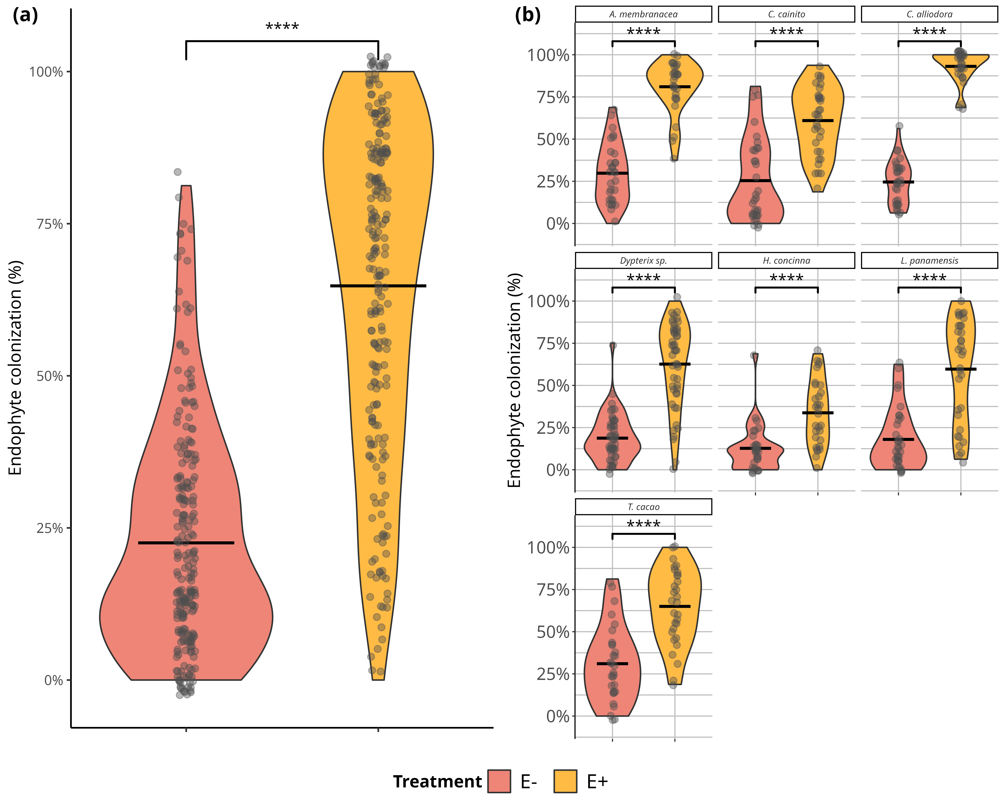

Foliar endophytic fungi (FEF) colonization of seven tropical tree species in malt extract agar (MEA 2%). a) Comparison of mean percent colonization of leaves by FEF measured 7 days after placing leaf pieces on plates. Statistical significance was calculated with a Student’s t-Test. Violin plots show the distribution of colonization values for all tree species within treatment groups (*E-* and *E+*). b) Comparison of mean percent colonization of leaves by FEF measured 7 days after culture. Violin plots show the distribution of percent colonization values for each species per treatment group. Pink filled violins represent low FEF group (*E-*) and yellow filled violins represent high FEF group (*E+*). Significance levels are represented by ns (not significant) and asterisks [p < 0.05 (*), p < 0.01 (**), p < 0.001 (***), and p < 0.0001 (****)]

## 15.11 Figure S2a-S2b

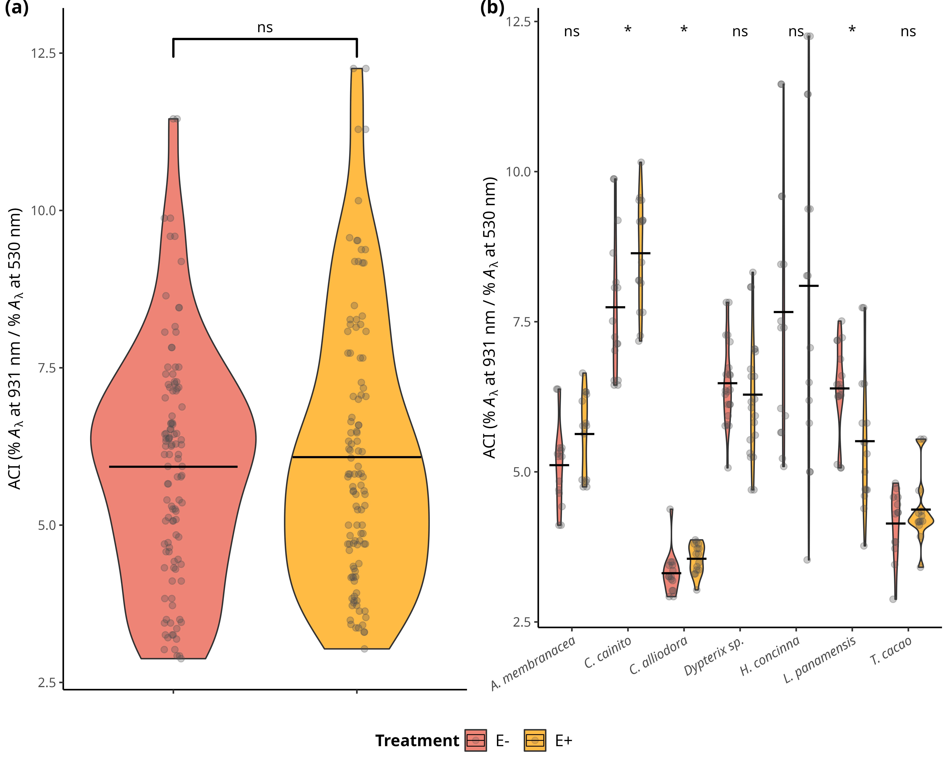

Distributions of values and means of anthocyanin content (ACI) in treatment groups (*E-* and *E+*) and tree species. a) Comparison of ACI means between treatment groups across individuals of all species. Statistical significance was calculated using a two-sided Student’s t-Test. b) Comparison of ACI means between treatment types of each species. Statistical significance was calculated with an analysis of variance (ANOVA). Pink filled violins represent low FEF group (*E-*) and yellow filed violins represent high FEF group (*E+*). SSignificance levels are represented by ns (not significant) and asterisks [p < 0.05 (*), p < 0.01 (**), p < 0.001 (***), and p < 0.0001 (****)].

## 15.12 Figure S3a-S3b

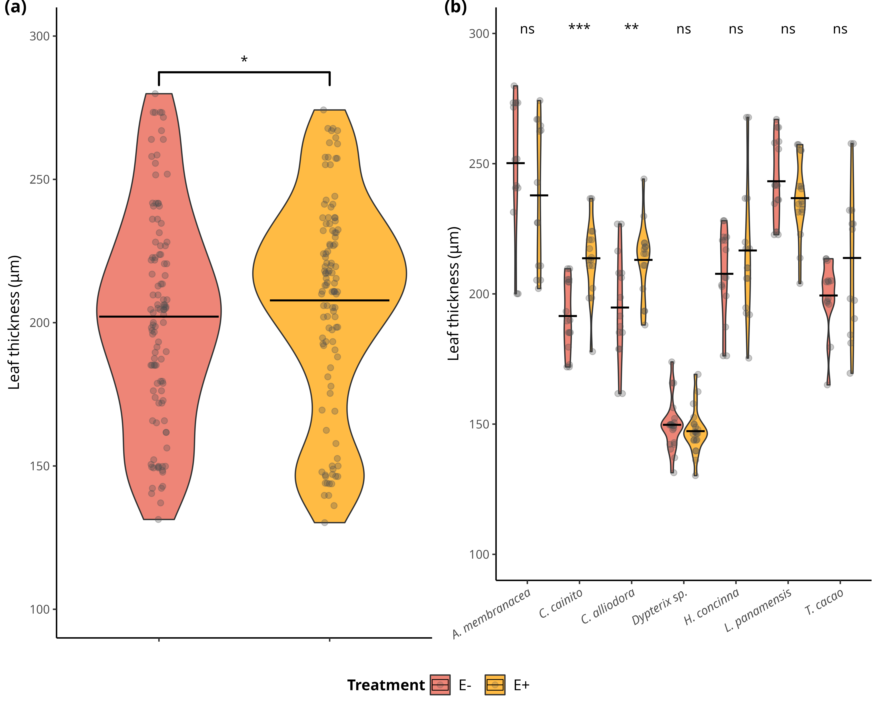

Distributions of values and means of leaf thickness (LT) (μg) in treatment groups (*E-* and *E+*) and tree species. a) Comparison of LT means between treatment groups across individuals of all species. Statistical significance was calculated using a two-sided Student’s t-Test. b) Comparison of LT means between treatment types of each species. Statistical significance was calculated with an analysis of variance (ANOVA). Pink filled violins represent low FEF group (*E-*) and yellow filed violins represent high FEF group (*E+*). Significance levels are represented by ns (not significant) and asterisks [p < 0.05 (*), p < 0.01 (**), p < 0.001 (***), and p < 0.0001 (****)].

## 15.13 Figure S4a-S4b

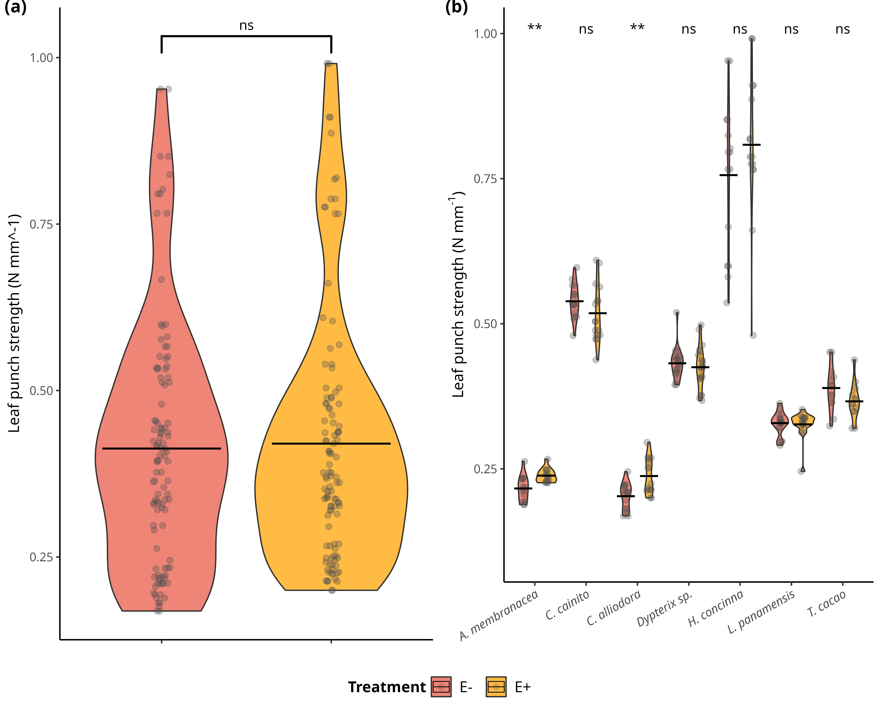

Distributions of values and means of leaf punch strength (LPS) (N mm^-1) in treatment groups (*E-* and *E+*) and tree species. a) Comparison of LPS means between treatment groups across individuals of all species. Statistical significance was calculated using a two-sided Student’s t-Test. b) Comparison of LPS means between treatment types of each species. Statistical significance was calculated with an analysis of variance (ANOVA). Pink filled violins represent low FEF group (*E-*) and yellow filed violins represent high FEF group (*E+*). Significance levels are represented by ns (not significant) and asterisks [p < 0.05 (*), p < 0.01 (**), p < 0.001 (***), and p < 0.0001 (****)].

## 15.14 Figure S5a-S5b

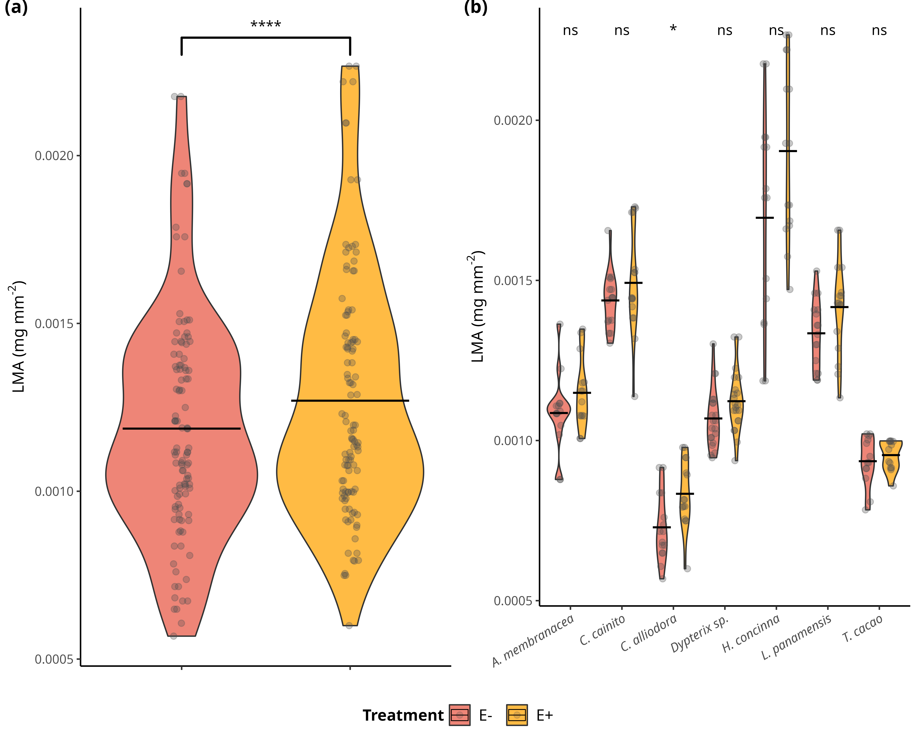

Distributions of values and means of leaf mass per area (LMA) (mg mm^2) in treatment groups (*E-* and *E+*) and tree species. a) Comparison of LMA means between treatment groups across individuals of all species. Statistical significance was calculated using a two-sided Student’s t-Test. b) Comparison of LMA means between treatment types of each species. Statistical significance was calculated with an analysis of variance (ANOVA). Pink filled violins represent low FEF group (*E-*) and yellow filed violins represent high FEF group (*E+*). Significance levels are represented by ns (not significant) and asterisks [p < 0.05 (*), p < 0.01 (**), p < 0.001 (***), and p < 0.0001 (****)].

## 15.15 Figure S6a-S6b

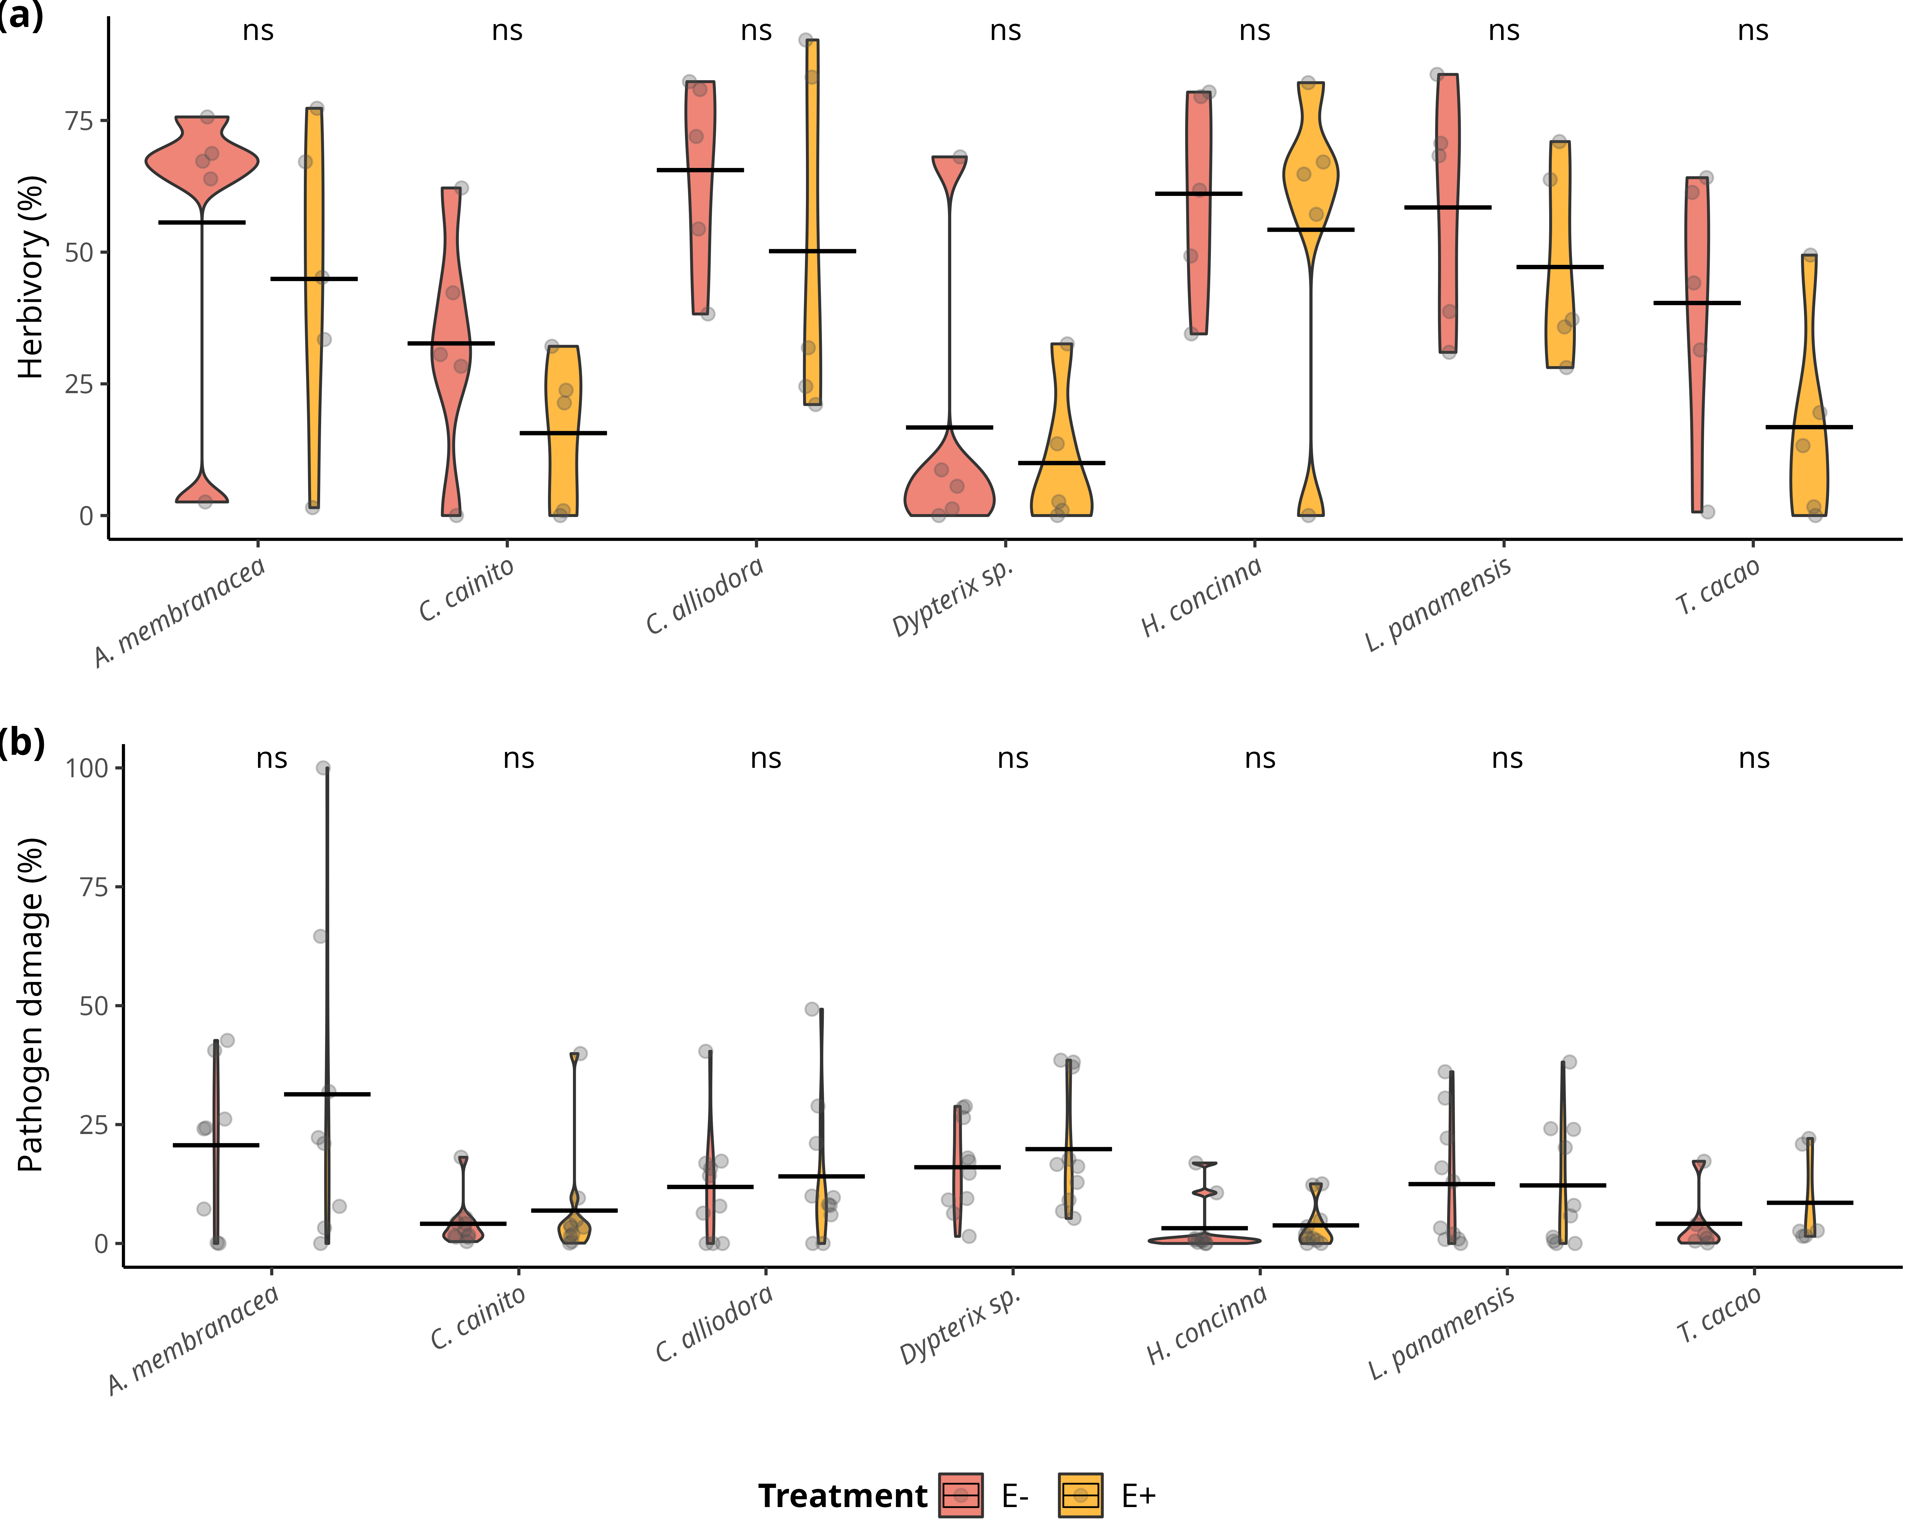

Distributions of values and means of herbivory (%) and pathogen damage caused by *Atta colombica* and *Calonectria* sp. , respectively, in treatment groups (*E-* and *E+*) per tree species. a) Comparison of herbivory (%) means between treatment groups across individuals of all species. b) Comparison of pathogen (%) means between treatment groups across individuals of all species. Pink filled violins represent low FEF group (*E-*) and yellow filed violins represent high FEF group (*E+*). Statistical significance was calculated with an analysis of variance (ANOVA). Significance levels are represented by ns (not significant) and asterisks [p < 0.05 (*), p < 0.01 (**), p < 0.001 (***), and p < 0.0001 (****)].

## 15.16 Figure S7

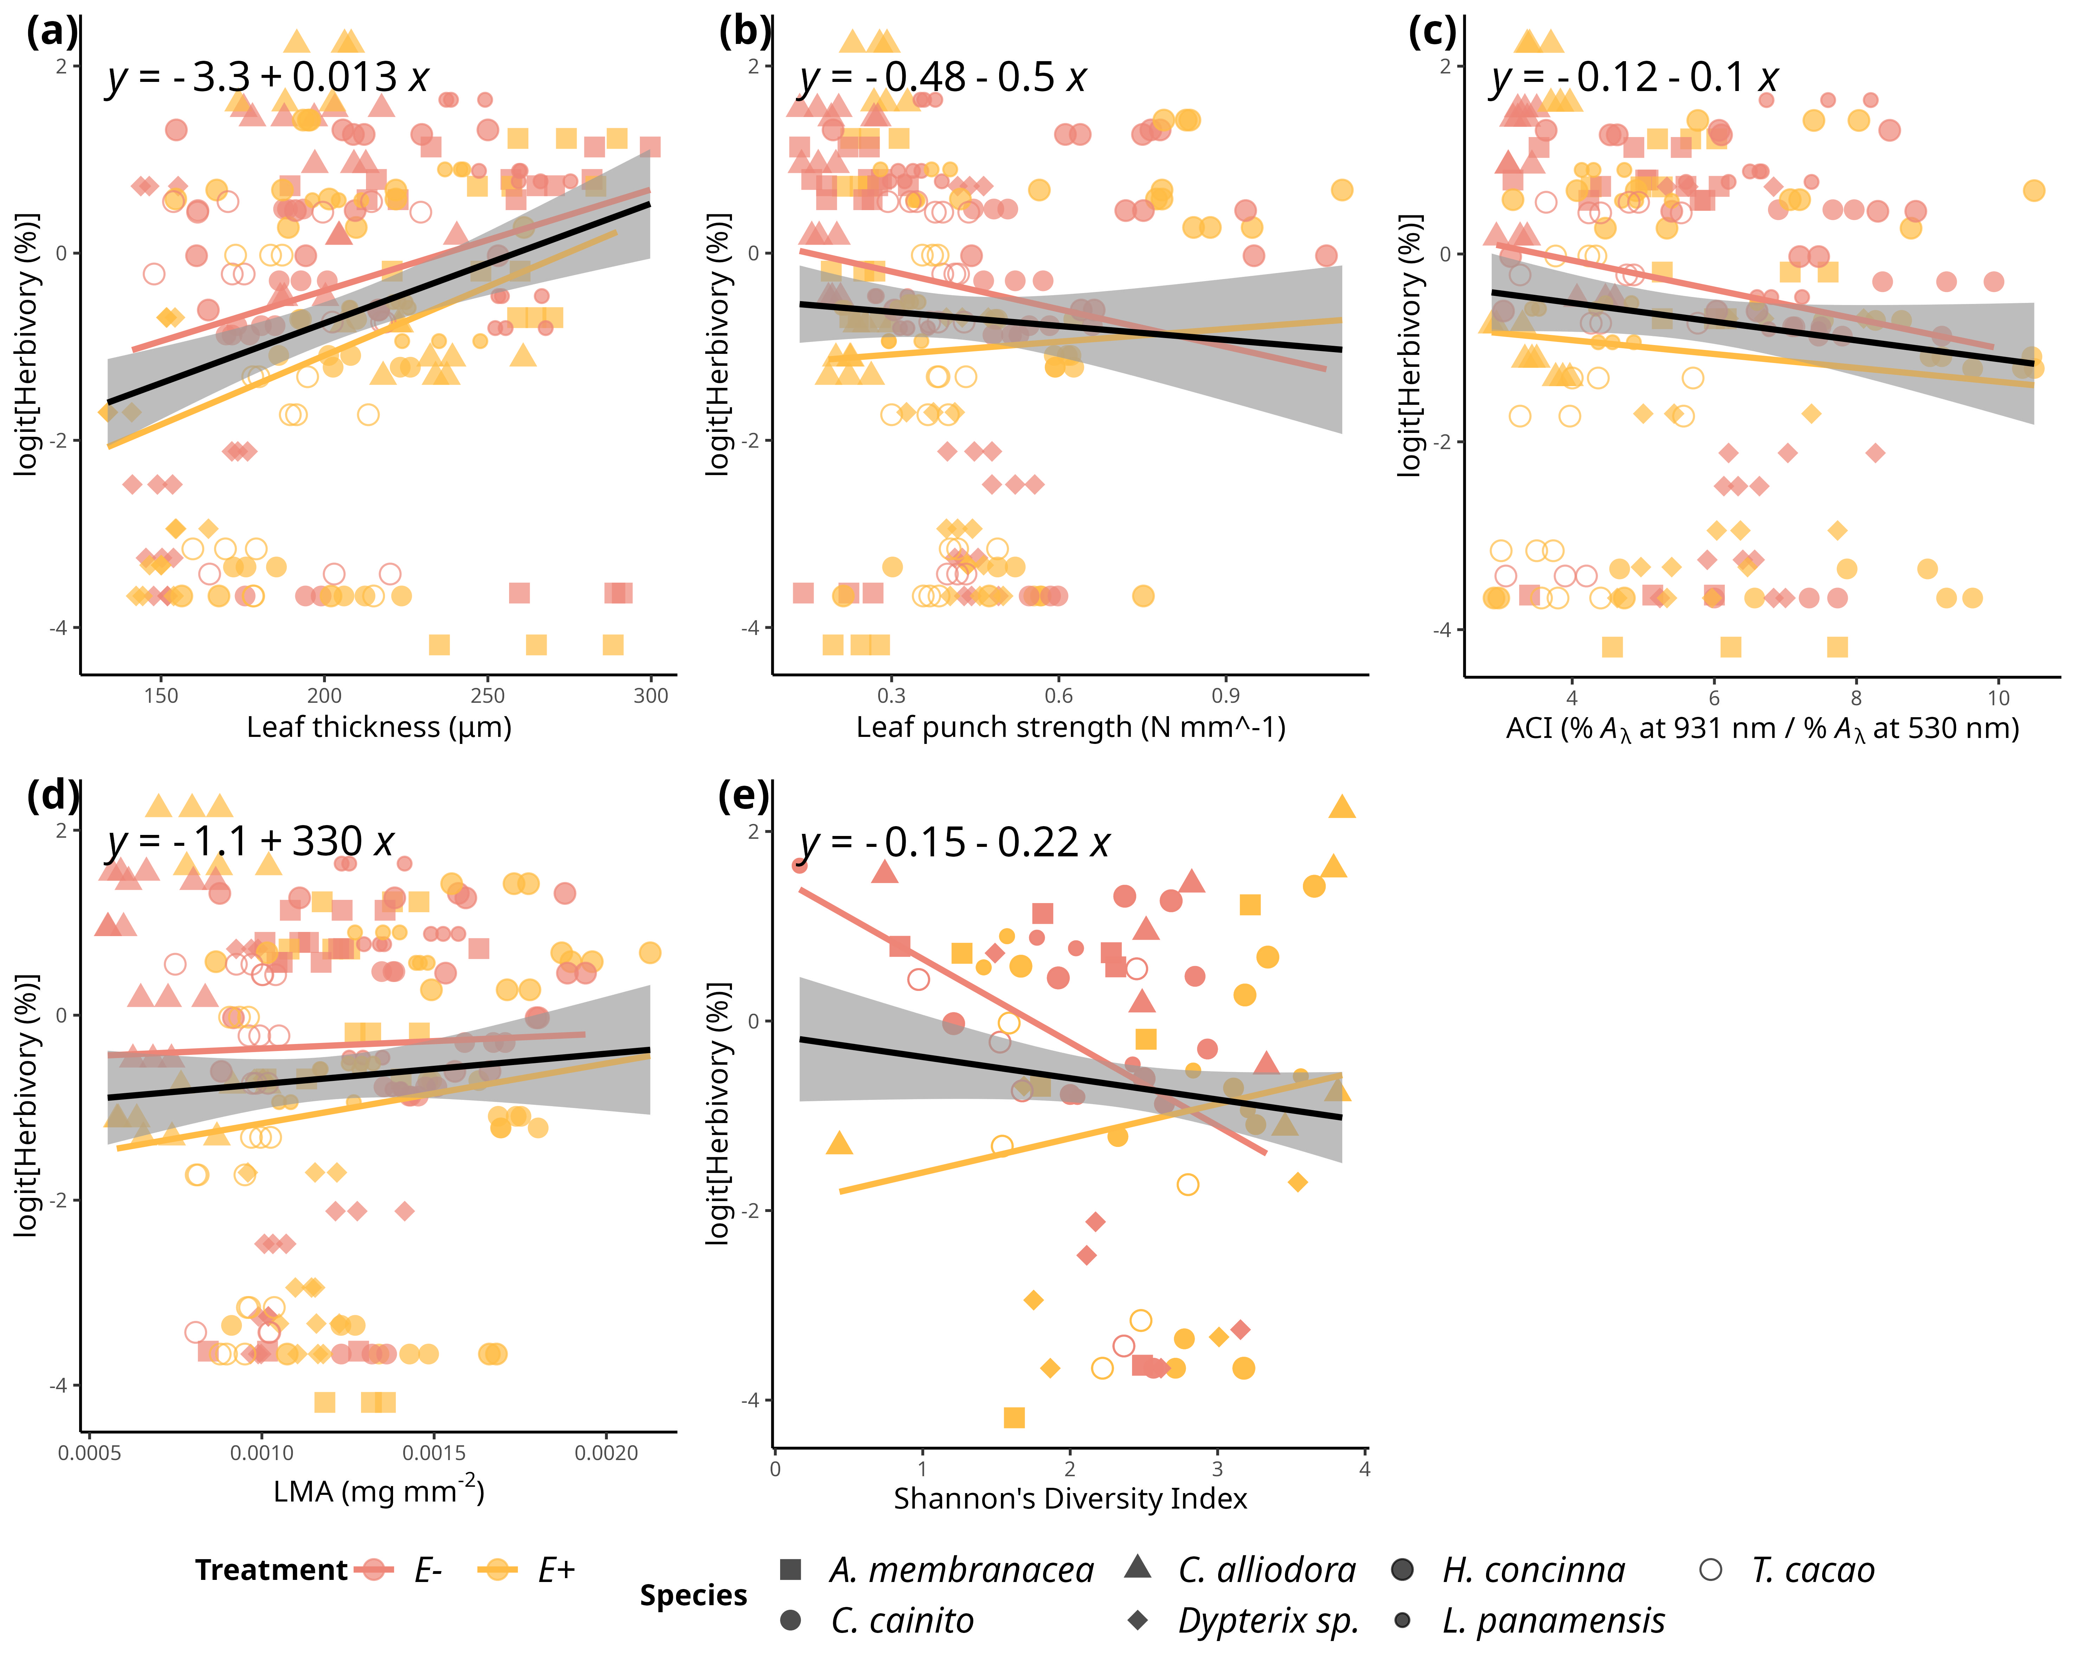

Simple linear regressions of logit transfomed herbivory (%) and and leaf functional traits. a) Herbivory *vs.* leaf thickness (LT) (μg) (R2-adjusted= 0.0811, *p* < 0.0001). b) Herbivory *vs.* LPS (N mm-1) (R2-adjusted= -0.0018, *p* = 0.429)). c) Herbivory *vs.* ACI (R2-adjusted= 0.0071, *p* = 0.116). d) Pathogen *vs.* LMA (mg mm^2) (R2-adjusted= -0.0008, *p* = 0.36). e) Herbivory *vs.* Shannon diversity index (R2-adjusted= 0.007 , *p* = 0.12). Pink filled line and shapes represent low FEF group (*E-*) and yellow filled line and shapes represent high FEF group (*E+*). Black line represents the linear regression on all observations. Significance levels are represented by ns (not significant) and asterisks [p < 0.05 (*), p < 0.01 (**), p < 0.001 (***), and p < 0.0001 (****)].

## 15.17 Figure S8

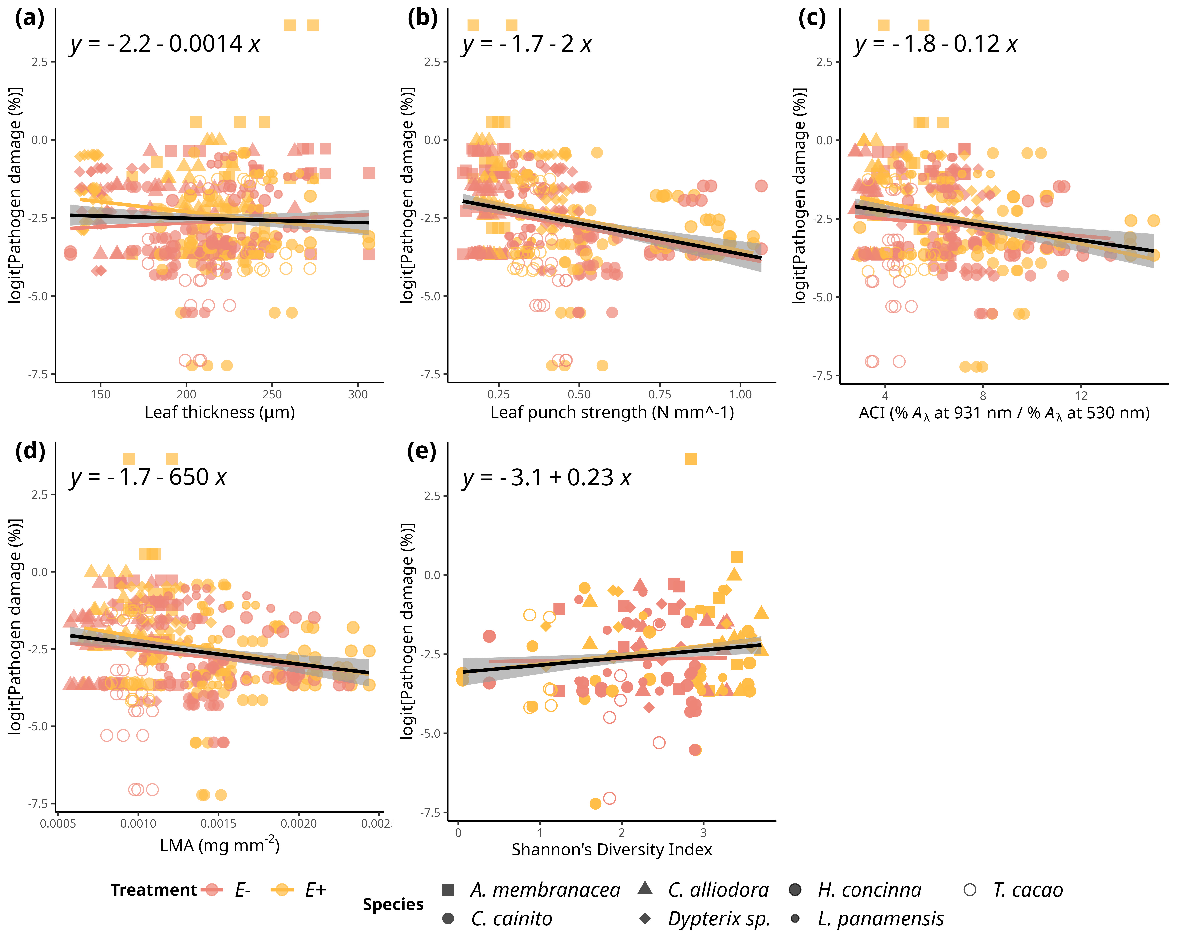

Simple linear regressions of logit transformed pathogen damage (%) and and leaf functional traits. a) Pathogen damage *vs.* leaf thickness (LT) (μg) (R2-adjusted= -0.0013, *p* = 0.482). b) Pathogen damage *vs.* LPS (N mm-1) (R2-adjusted= 0.0782, *p* < 0.0001)). c) Pathogen damage *vs.* ACI (R2-adjusted= 0.0338, *p* < 0.001). d) Pathogen *vs.* LMA (mg mm^2) (R2-adjusted= 0.0295, *p* < 0.001). e) Pathogen damage *vs.* Shannon diversity index (R2-adjusted= 0.0152 , *p* < 0.001). Pink filled line and shapes represent low FEF group (*E-*) and yellow filled line and shapes represent high FEF group (*E+*). Black line represents the linear regression on all observations. Significance levels are represented by ns (not significant) and asterisks [p < 0.05 (*), p < 0.01 (**), p < 0.001 (***), and p < 0.0001 (****)].

## 15.18 Figure S9

*Simple linear regression on even and tiered mock FEF communities.*

## 15.19 Supplementary Material - Methods

#### 15.18.0.1 Seed collection and sterilization

Seeds were prepared for germination within 24 hours of fruit collection on BCI, January - April 2019. Fruits were peeled to extract seeds, cleaned, put in water to swell embryo, sterilized, and planted in sterile soil germination trays (75% soil; 25% sand). Soil was autoclaved at 121 °C in two, one hour cycles. Seeds were surface sterilized using 10% bleach for 3 minutes followed by 70% ethanol for 3 minutes.

#### 15.18.0.2 Germination Tray and 24-pot tray sterilization

Plastic germination trays and 24-cell trays were sterilized in a 10% bleach bath for 20 minutes, sprayed with 70% ethanol, and paper towel dried right before adding soil/planting.

#### 15.18.0.3 Planting in germination trays

The sterile soil is added to an sterilized plastic germination tray, combined with water well until it is wet and has a cookie dough-like consistency. Seeds were then added to moist soil. A sprinkle of dry soil is added to as a top layer to discourage pathogen spores from landing in the wet surface soil.

#### 15.18.0.4 Seedling transfer into pots

Once seeds germinated, seedlings were transferred to pots by wetting the soil and extracting intact root system. Seedling were immediately placed in pot with sterile soil using a small shovel after uprooting from germination tray. Hands were sprayed with 70% ethanol when switching from handling one species to handling another. Plants were watered as needed at the soil level and 25mL of MiracleGro all-purpose plant food was added to every seedling once a month throughout entirety of experiment.